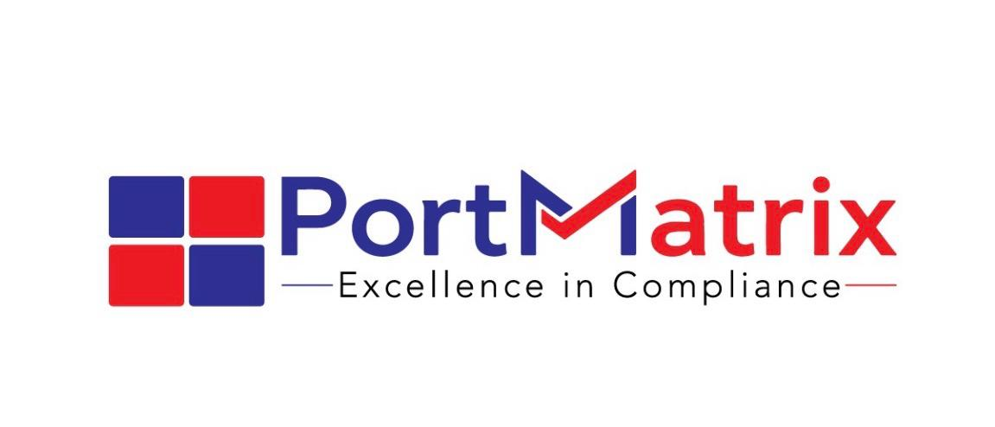
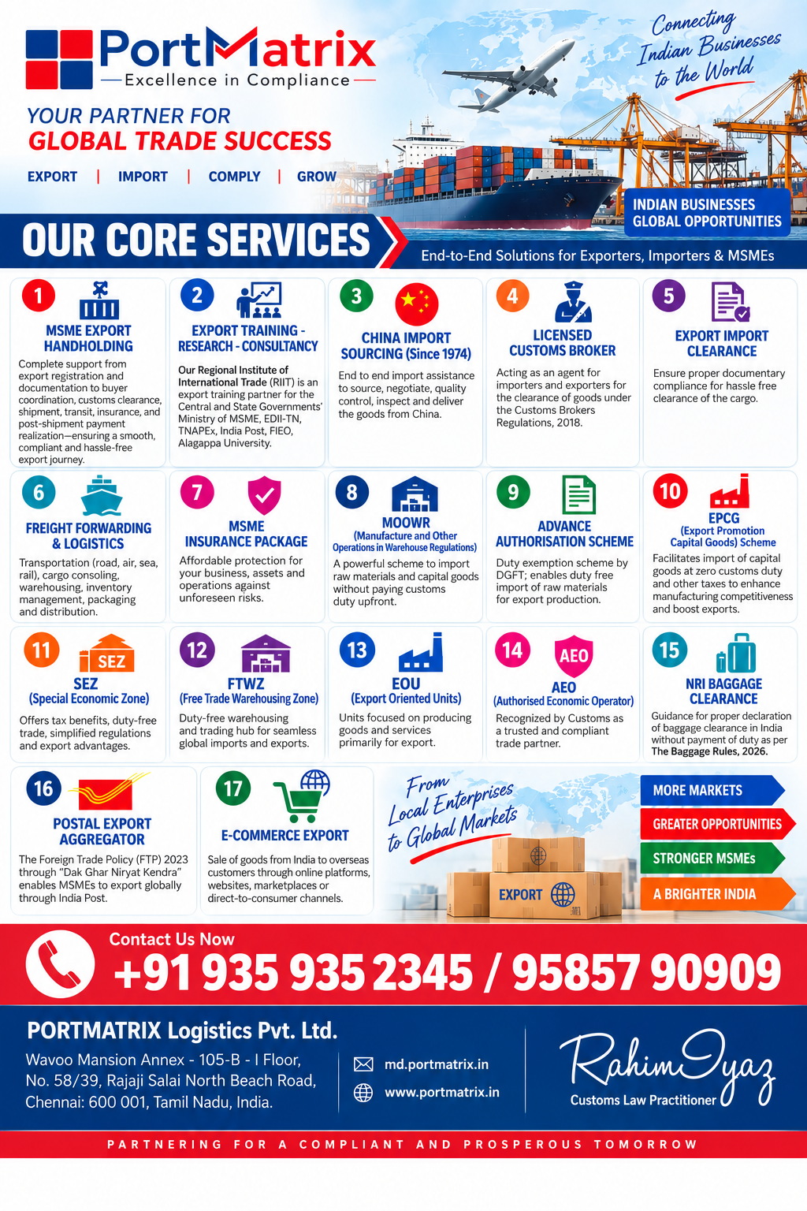

About Us:

PORTMATRIX is a Customs Broking and **End-to-End Export Handholding** company supporting exporters and importers in navigating Customs, DGFT and international trade procedures with accuracy, speed and transparency.

Our core strength is **Export Handholding—from product selection, HS Code classification, export policy and market identification to documentation, regulatory compliance, customs clearance, logistics and realisation of export proceeds.**

We also provide **DGFT consultancy, Allied Acts inputs, EXIM analytics, Global Market & International Trade Intelligence, RTA/FTA advisory, Import Penetration & Trade Intensity analysis, SHI/RHI and Export Propensity analysis, export market strategy, competitor analysis and export packaging guidance.**

**PORTMATRIX— Excellence in EXIM Compliance.**

Our allied concern, REGIONAL INSTITUTE OF INTERNATIONAL TRADE (RIIT) supports entrepreneurs, professionals and students through International Trade Training, Research and Consultancy, serving as an Academic Centre of Excellence in International Trade.

Our MD’s Profile:




M.Com, MBA, M.Phil., PGDIBO
PPIBAMI (IIFT), CBLR F-Card

- Our Managing Director Mr. Rahim Iyaz is a Government Licensed Customs Broker, having a vintage experience in the foreign trade since 1996.
- Worked extensively in the international markets viz Republic of Maldives, Singapore, China, Hong Kong, Malaysia, Thailand, UAE, Saudi Arabia and Sri Lanka.
- Having worked with India's largest banking group State Bank of India in Risk Mitigation Management.
- Authorised Resource Person in export training for the Govt. of India-MSME, EDII-TN, TNAPEx, FIEO, Alagappa University.

Core Services
- MSME Export Handholding:
- Complete support from export registration and documentation to buyer coordination, customs clearance, shipment, transit, insurance, and post-shipment payment realization—ensuring a smooth, compliant, and hassle-free export journey.

- Export Training - Research - Consultancy:
- Our Regional Institute of International Trade (RIIT) is an export training partner for both the Central and State Governments’ Ministry of MSME, EDII-TN, TNAPEx, India Post, FIEO, Alagappa University.

- China Import Sourcing (Since 1974):
- We facilitate end to end import assistance to source, negotiate, quality control, inspect and deliver the goods from China.

- Licensed Customs Broker:
- We act as an agent on behalf of importers and exporters; for the clearance of imported or export goods under the provisions of the Customs Brokers Regulations, 2018.

- Export Import Clearance:
- We ensure proper documentary compliance for hassle free clearance of the cargo.

- Freight Forwarding & Logistics:
- We provide logistics services which include transportation (by road, air, sea, or rail), cargo consoling, warehousing, inventory management, packaging, and distribution.

- MSME Insurance Package:
- Affordable protection for your business, assets, and operations against unforeseen risks.

- MOOWR (Manufacture and Other Operations in Warehouse Regulations):
- MOOWR or Section 65 Warehousing Unit is a powerful scheme that allows the manufacturers to import raw materials and capital goods without paying customs duty upfront.

- Advance Authorisation Scheme:
- It is a duty exemption scheme by DGFT; that enables duty free import of raw materials for export production.

- EPCG (Export Promotion Capital Goods) Scheme:
- This Scheme is to facilitate import of capital goods at zero customs duty and other taxes; for producing quality goods and services to enhance India’s manufacturing competitiveness to boost export capability.

- SEZ (Special Economic Zone):
- SEZ offers tax benefits, duty-free trade, simplified regulations, and export advantages.

- FTWZ (Free Trade Warehousing Zone):
- Duty-free warehousing and trading hub for seamless global imports and exports.

- EOU (Export Oriented Units):
- These Units focused on producing goods and services primarily for export.

- AEO (Authorised Economic Operator):
- This is a business entity involved in international trade that is recognized by the Customs as a trusted and compliant trade partner.

- NRI Baggage Clearance:
- We advise the NRI Clients in proper declaration of their baggage clearance in India; without payment of duty as per The Baggage Rules, 2026.

- Postal Export Aggregator:
- The Foreign Trade Policy (FTP) 2023 through “Dak Ghar Niryat Kendra” enables MSMEs to export globally through India Post.*

- E-Commerce Export:

E-commerce export refers to the sale of goods from India to overseas customers through online platforms, websites, marketplaces, or direct-to-consumer channels.

- MSME EXPORT HANDHOLDING PACKAGE

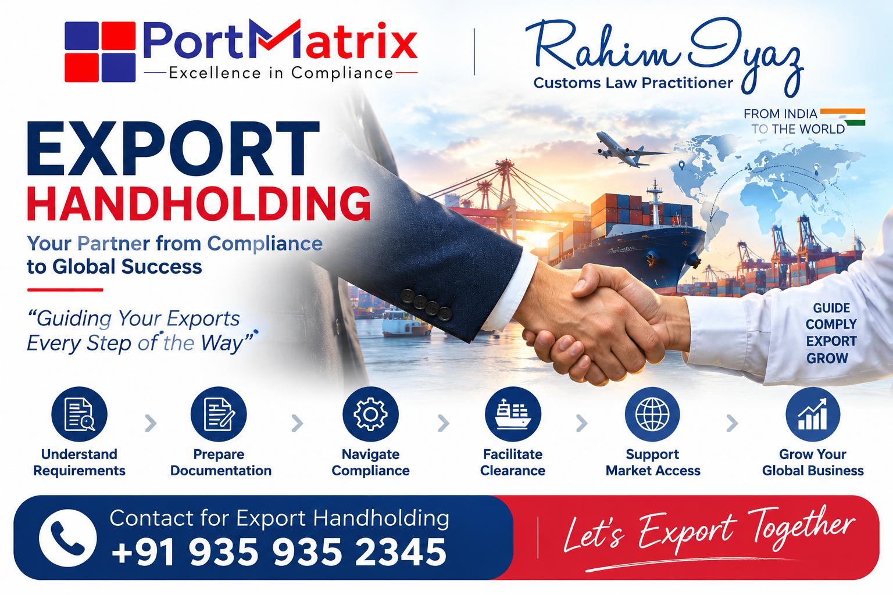

End-to-End Export Facilitation Process
Complete support from export registration and documentation to buyer coordination, customs clearance, shipment, transit, insurance, and post-shipment payment realization—ensuring a smooth, compliant, and hassle-free export journey.

End to End Export Handholding
Phase 1: Business Setup and Registration

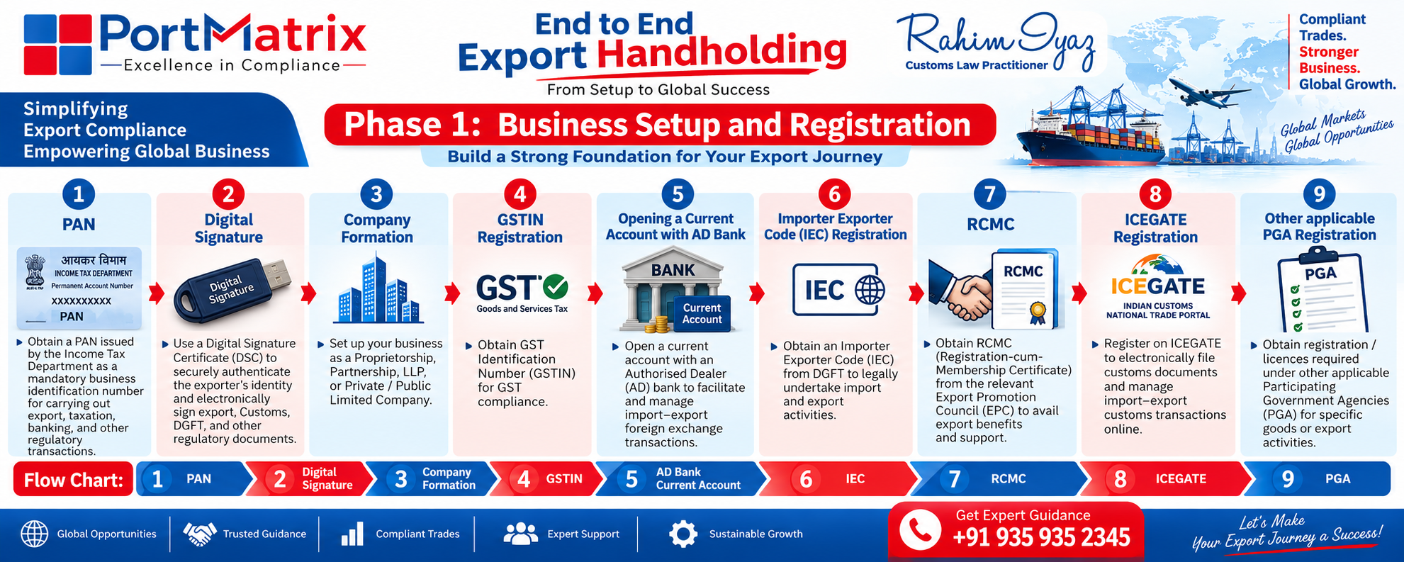

- PAN
- Obtain a PAN issued by the Income Tax Department as a mandatory business identification number for carrying out export, taxation, banking, and other regulatory transactions.

- Digital Signature
- Use a Digital Signature Certificate (DSC) to securely authenticate the exporter’s identity and electronically sign export, Customs, DGFT, and other regulatory documents.

- Company Formation:
- Proprietorship, Partnership, LLP, Private / Public Limited Company

- GSTIN Registration:
- Obtain GST Identification Number (GSTIN) for GST compliance.

- Opening a Current Account with AD Bank
- Open a current account with an Authorised Dealer (AD) bank to facilitate and manage import–export foreign exchange transactions.

- Importer Exporter Code (IEC) Registration
- Obtain an Importer Exporter Code (IEC) from DGFT to legally undertake import and export activities.

- RCMC
- Obtain RCMC (Registration-cum-Membership Certificate) from the relevant Export Promotion Council (EPC) to avail export benefits and support.

- ICEGATE Registration
- Register on ICEGATE to electronically file customs documents and manage import–export customs transactions online.

- Other applicable PGA Registration
- Obtain registration / licences required under other applicable Participating Government Agencies (PGA) for specific goods or export activities.

- Flow Chart: PAN → Digital Signature → Company Formation → GSTIN → AD Bank Current Account → IEC → RCMC → ICEGATE → PGA.

Phase 2: Pre Export Planning

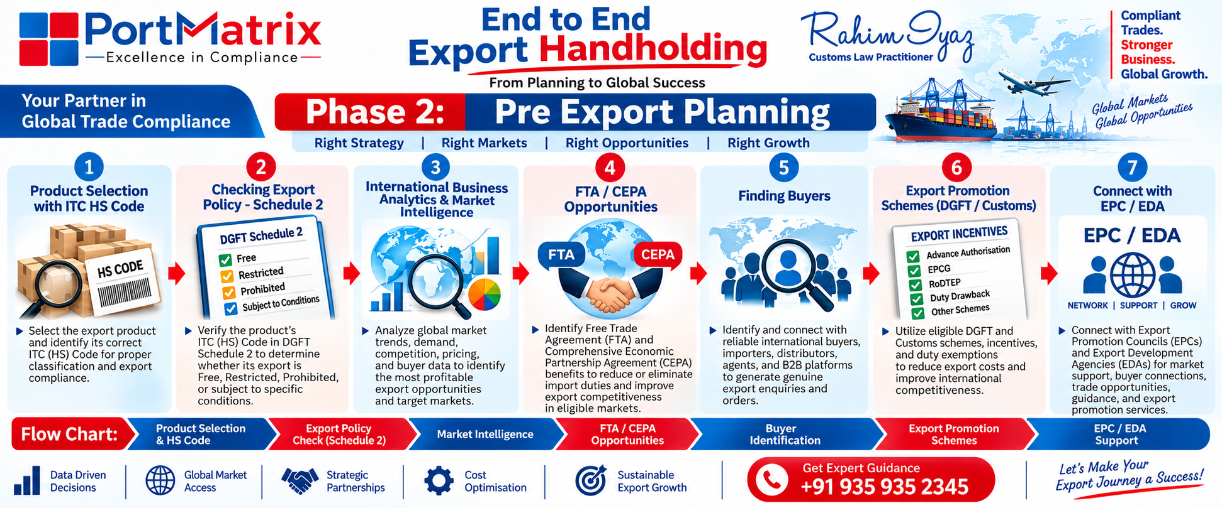

- Product Selection with ITC HS Code
- Select the export product and identify its correct ITC (HS) Code for proper classification and export compliance.

- Checking Export Policy - Schedule 2
- Verify the product’s ITC (HS) Code in DGFT Schedule 2 to determine whether its export is Free, Restricted, Prohibited, or subject to specific conditions.

- International Business Analytics & Market Intelligence
- Analyze global market trends, demand, competition, pricing, and buyer data to identify the most profitable export opportunities and target markets.

- FTA / CEPA Opportunities
- Identify Free Trade Agreement (FTA) and Comprehensive Economic Partnership Agreement (CEPA) benefits to reduce or eliminate import duties and improve export competitiveness in eligible markets.

- Finding Buyers
- Identify and connect with reliable international buyers, importers, distributors, agents, and B2B platforms to generate genuine export enquiries and orders.

- Export Promotion Schemes (DGFT / Customs)
- Utilize eligible DGFT and Customs schemes, incentives, and duty exemptions to reduce export costs and improve international competitiveness.

- Connect with EPC / EDA
- Connect with Export Promotion Councils (EPCs) and Export Development Agencies (EDAs) for market support, buyer connections, trade opportunities, guidance, and export promotion services.
Flow Chart: Product Selection & HS Code → Export Policy Check → Market Intelligence → FTA / CEPA Opportunities → Buyer Identification → Export Promotion Schemes → EPC / EDA Support.

Phase 3: Buyer Development and Commercial Negotiations

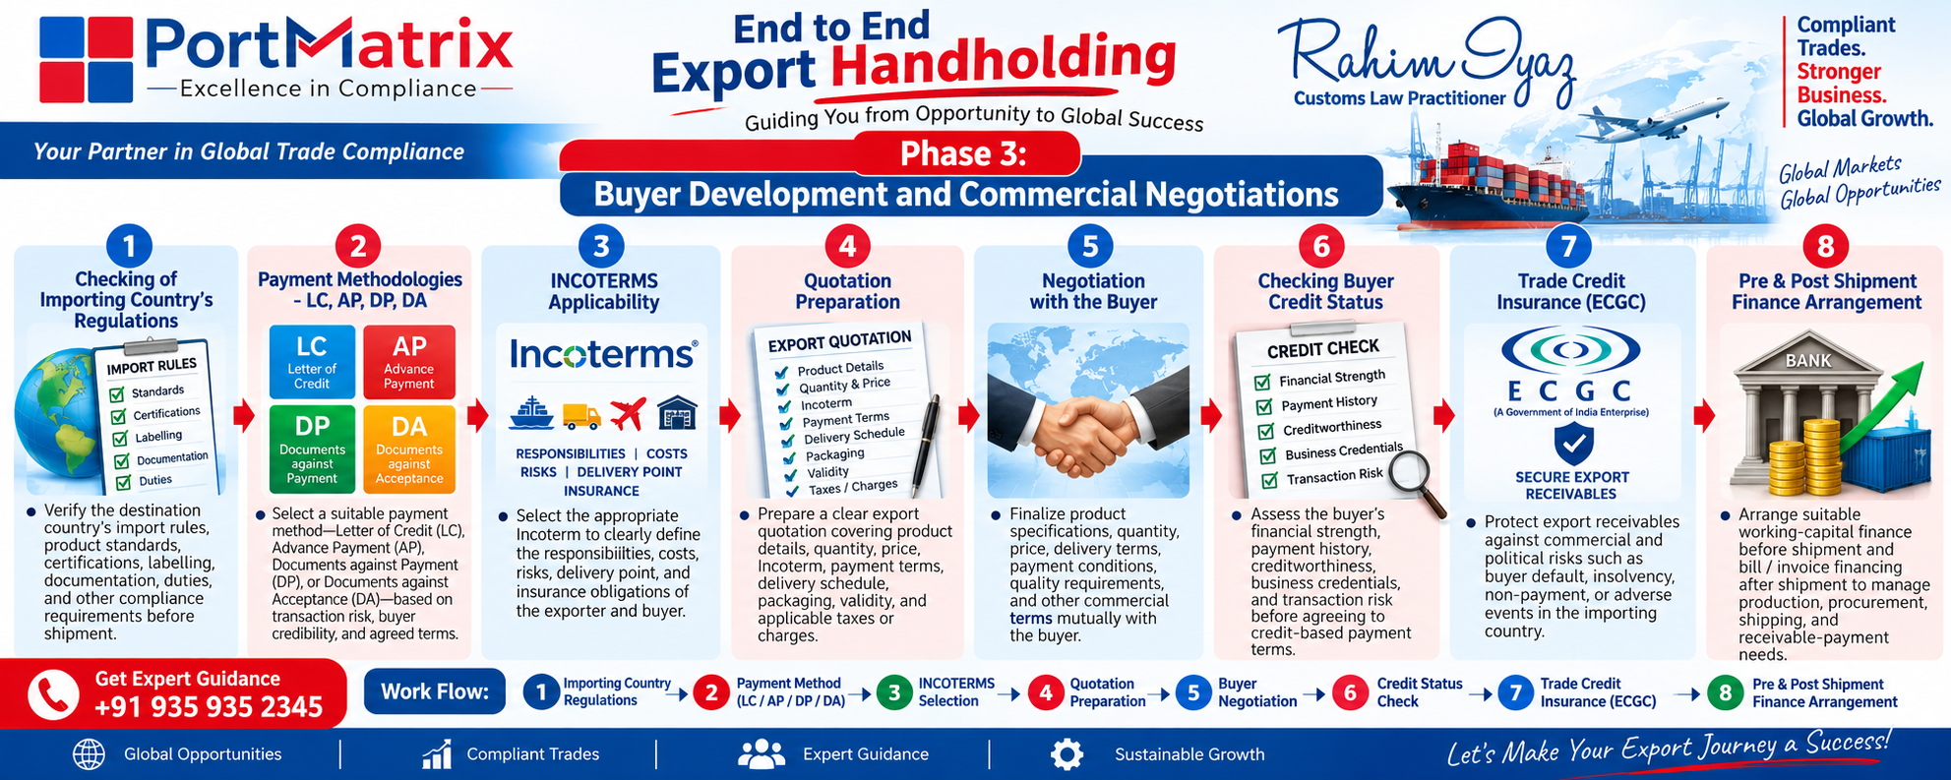

- Checking of Importing Country’s Regulations
- Verify the destination country’s import rules, product standards, certifications, labelling, documentation, duties, and other compliance requirements before shipment.

- Payment Methodologies - LC, AP, DP, DA
- Select a suitable payment method—Letter of Credit (LC), Advance Payment (AP), Documents against Payment (DP), or Documents against Acceptance (DA)—based on transaction risk, buyer credibility, and agreed terms.

- INCOTERMS Applicability
- Select the appropriate Incoterm to clearly define the responsibilities, costs, risks, delivery point, and insurance obligations of the exporter and buyer.

- Quotation Preparation
- Prepare a clear export quotation covering product details, quantity, price, Incoterm, payment terms, delivery schedule, packaging, validity, and applicable taxes or charges.

- Negotiation with the Buyer
- Finalize product specifications, quantity, price, delivery terms, payment conditions, quality requirements, and other commercial terms mutually with the buyer.

- Checking Buyer Credit Status
- Assess the buyer’s financial strength, payment history, creditworthiness, business credentials, and transaction risk before agreeing to credit-based payment terms.

- Trade Credit Insurance (ECGC)
- Protect export receivables against commercial and political risks such as buyer default, insolvency, non-payment, or adverse events in the importing country.

- Pre & Post Shipment Finance Arrangement
- Arrange suitable working-capital finance before shipment and bill / invoice financing after shipment to manage production, procurement, shipping, and receivable-payment needs.

Flow Chart: Importing Country Regulations → Payment Method (LC / AP / DP / DA) → INCOTERMS Selection → Quotation Preparation → Buyer Negotiation → Credit Status Check → Trade Credit Insurance (ECGC) → Pre & Post-Shipment Finance Arrangement.

Phase 4: Pre Shipment Procedures
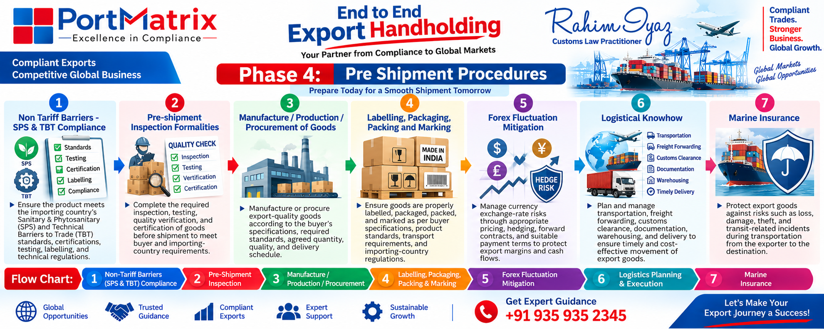

- Non Tariff Barriers - SPS & TBT Compliance
- Ensure the product meets the importing country’s Sanitary & Phytosanitary (SPS) and Technical Barriers to Trade (TBT) standards, certifications, testing, labelling, and technical regulations.

- Pre-shipment Inspection Formalities
- Complete the required inspection, testing, quality verification, and certification of goods before shipment to meet buyer and importing-country requirements.

- Manufacture / Production / Procurement of Goods
- Manufacture or procure export-quality goods according to the buyer’s specifications, required standards, agreed quantity, quality, and delivery schedule.

- Labelling, Packaging, Packing and Marking
- Ensure goods are properly labelled, packaged, packed, and marked as per buyer specifications, product standards, transport requirements, and importing-country regulations.

- Forex Fluctuation Mitigation
- Manage currency exchange-rate risks through appropriate pricing, hedging, forward contracts, and suitable payment terms to protect export margins and cash flows.

- Logistical Knowhow
- Plan and manage transportation, freight forwarding, customs clearance, documentation, warehousing, and delivery to ensure timely and cost-effective movement of export goods.

- Marine Insurance
- Protect export goods against risks such as loss, damage, theft, and transit-related incidents during transportation from the exporter to the destination.
Flow Chart: Non-Tariff Barriers (SPS & TBT) Compliance → Pre-Shipment Inspection → Manufacture / Production / Procurement → Labelling, Packaging, Packing & Marking → Forex Fluctuation Mitigation → Logistics Planning & Execution → Marine Insurance.

Phase 5: Shipment Procedures
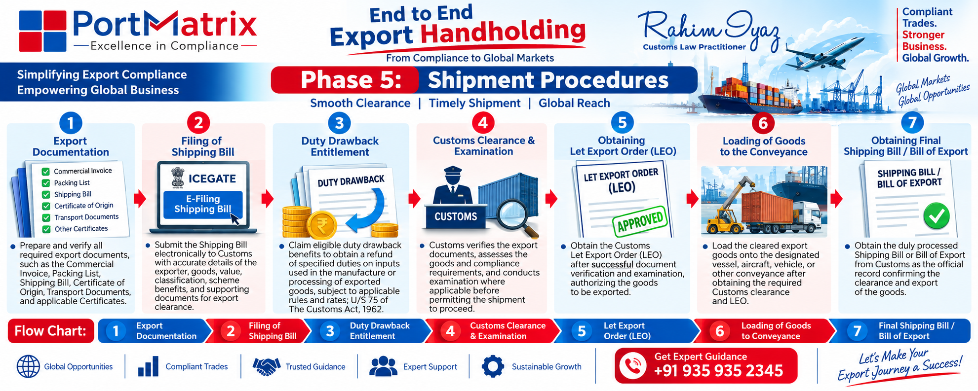

- Export Documentation
- Prepare and verify all required export documents, such as the Commercial Invoice, Packing List, Shipping Bill, Certificate of Origin, Transport Documents, and applicable Certificates.

- Filing of Shipping Bill
- Submit the Shipping Bill electronically to Customs with accurate details of the exporter, goods, value, classification, scheme benefits, and supporting documents for export clearance.

- Duty Drawback Entitlement
- Claim eligible duty drawback benefits to obtain a refund of specified duties on inputs used in the manufacture or processing of exported goods, subject to applicable rules and rates; U/S 75 of The Customs Act, 1962.

- Customs Clearance & Examination
- Customs verifies the export documents, assesses the goods and compliance requirements, and conducts examination where applicable before permitting the shipment to proceed.

- Obtaining Let Export Order (LEO)
- Obtain the Customs Let Export Order (LEO) after successful document verification and examination, authorizing the goods to be exported.

- Loading of Goods to the Conveyance
- Load the cleared export goods onto the designated vessel, aircraft, vehicle, or other conveyance after obtaining the required Customs clearance and LEO.

- Obtaining Shipping Bill / Bill of Export
- Obtain the duly processed Shipping Bill or Bill of Export from Customs as the official record confirming the clearance and export of the goods.
Flow Chart: Export Documentation → Filing of Shipping Bill → Duty Drawback Entitlement → Customs Clearance & Examination → Obtaining Let Export Order (LEO) → Loading of Goods into Conveyance → Obtaining Final Shipping Bill / Bill of Export.

Phase 6: Post Shipment and Realisation Procedures
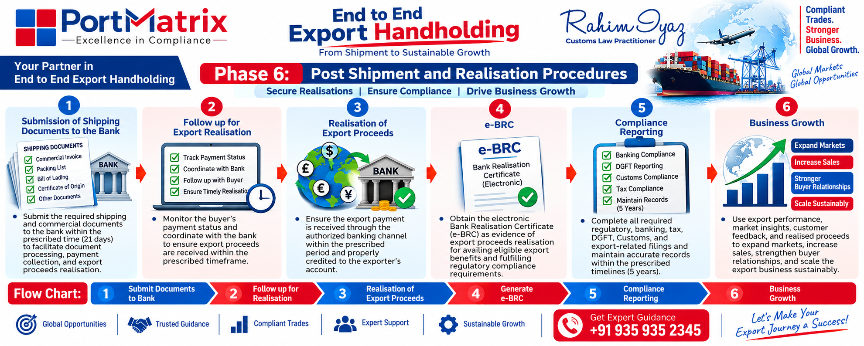

- Submission of Shipping Documents to the Bank
- Submit the required shipping and commercial documents to the bank within the prescribed time(21 days) to facilitate document processing, payment collection, and export proceeds realisation.

- Follow up for Export Realisation
- Monitor the buyer’s payment status and coordinate with the bank to ensure export proceeds are received within the prescribed timeframe.

- Realisation of Export Proceeds
- Ensure the export payment is received through the authorized banking channel within the prescribed period and properly credited to the exporter’s account.

- e-BRC
- Obtain the electronic Bank Realisation Certificate (e-BRC) as evidence of export proceeds realisation for availing eligible export benefits and fulfilling regulatory compliance requirements.

- Compliance Reporting
- Complete all required regulatory, banking, tax, DGFT, Customs, and export-related filings and maintain accurate records within the prescribed timelines (5 years).

- Business Growth
- Use export performance, market insights, customer feedback, and realised proceeds to expand markets, increase sales, strengthen buyer relationships, and scale the export business sustainably.
Flow Chart: Submission of Shipping Documents to Bank → Follow-up for Export Realisation → Realisation of Export Proceeds → Generation of e-BRC → Compliance Reporting → Business Growth.

2. Export Training - Research - Consultancy



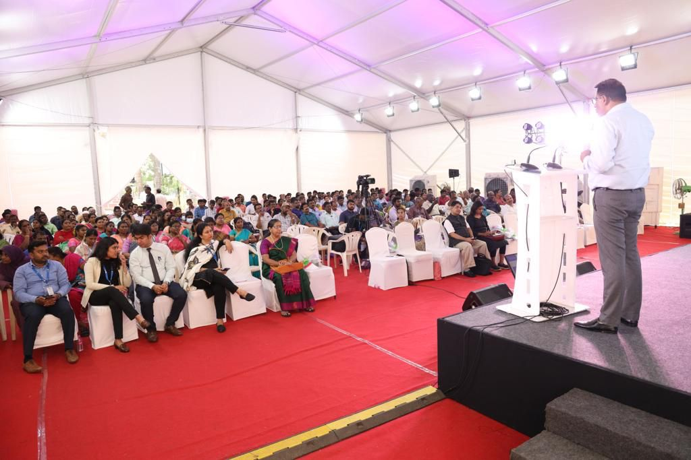

- Our Regional Institute of International Trade (RIIT) is an export training partner for both the Central and State Governments’ Ministry of MSME, EDII-TN, TNAPEx, India Post, FIEO, Alagappa University.

- We impart Export Import Training - Research - Consultancy for the employees of Corporates, MSMEs on a structural basis.

Our Courses:

- Export Startup Procedure:
- A step-by-step process to start exporting, covering registration, documentation, compliance, buyer coordination, shipping, customs, and payment realization.

- The Customs Act. 1962:
- India’s key law governing the import, export, customs duties, clearance, and regulation of goods across its borders.

- The Customs Tariff Act, 1975:
- The law governing customs duties and tariffs on goods imported into or exported from India.

- Foreign Trade Policy 2023:
- The Act governing India’s Foreign Trade by facilitating imports and promoting exports.

- Customs Clearance Procedures:
- Complete process for documentation, customs compliance, duty assessment, examination, and timely clearance of import and export shipments.

- IGST in Export:
- GST provisions enabling exporters to claim zero-rated benefits, including export under LUT/Bond or payment of IGST with eligible refund.

- Foreign Exchange Management Act, 1999 (FEMA):
- India’s law regulating foreign exchange transactions, cross-border payments, and international trade-related financial dealings.

- Intellectual Property Rights (IPR):
- Legal protection for creations and commercial identity, covering Copyright, Trade Marks, Designs, and Geographical Indications (GI) under their respective laws.

- Allied Acts for Customs Clearance:
- Laws and regulations governing goods, licensing, restrictions, safety, taxation, and other requirements for compliant import and export customs clearance.

- Export Promotion Schemes (Advance Authorisation, EPCG, RoDTEP, Duty Drawback):
- Government schemes providing duty exemptions, remission, and refunds to reduce export costs and enhance global competitiveness.

- MOOWR Scheme:
- Enables manufacturers to import raw materials and capital goods into a bonded warehouse with deferred customs duty, supporting cost-effective manufacturing and exports.

- Postal / Courier / E-Commerce Export:
- Simplified export channels enabling MSMEs, artisans, and online sellers to reach global customers through postal, courier, and e-commerce platforms.

3. China Import Sourcing (Since 1974)

Explore our experience in China trade since 1974
China is called the factory of the world. It is being preferred over other countries due to lower cost and quality. Against the myth, China produces very high quality products.
↓
We facilitate end to end import assistance to source, negotiate, quality control, inspect and deliver the goods from China.
- Permanent Chinese speaking staff
- Factory inspection
- Hassle free FCL / LCL cargo delivery
- Door to door delivery from China
- Utmost transparency with agreed service charge.
- Canton Fair arrangements
- China visa and ticketing

The Gateway to China Trade

Specialized China import consultant from sourcing till delivery

Our late Founder Mr. M.A. Izzadeen had started his Gem Stones trading in Hong Kong during the year 1974. Over the period of more than 5 decades, we have expanded our business errands in China and India.
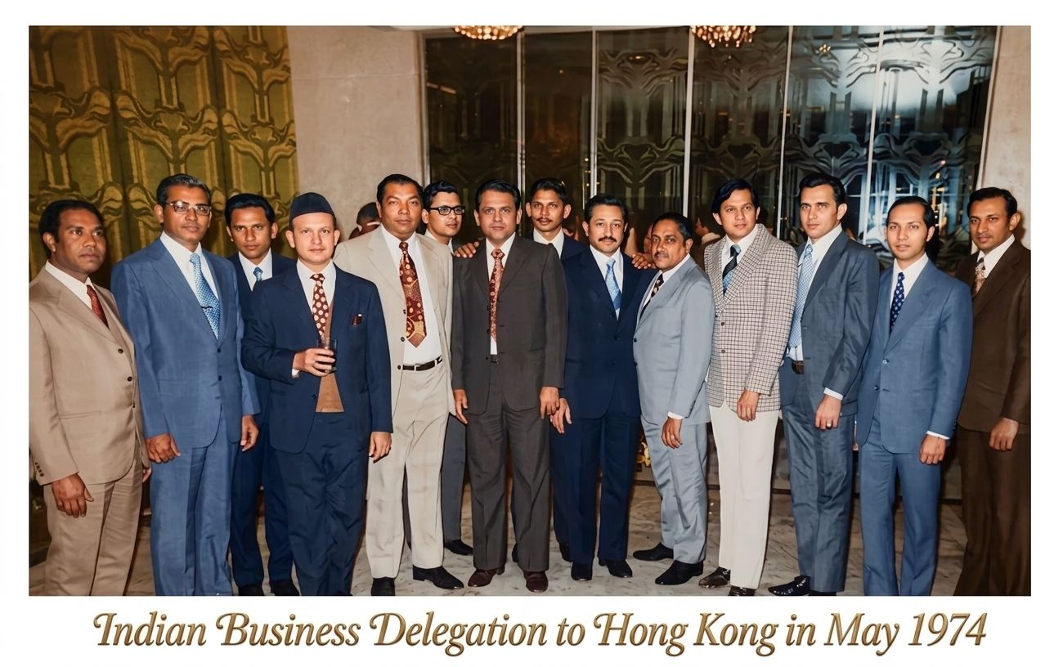
Our trade link with Hong Kong and China dated back to 1974. Our late Founder Mr. Izzadeen is seen 3rd from left (behind the person wearing cap). This was a Business Delegation from India (Kayalpattinam) to Hong Kong in 1974.

China Sourcing
- China is a global hub for manufacturing, as well as the largest exporter of goods in the world.
- China is also the world's fastest growing consumer market and second largest importer of goods.
- China exports to almost all the continents from Africa to America.

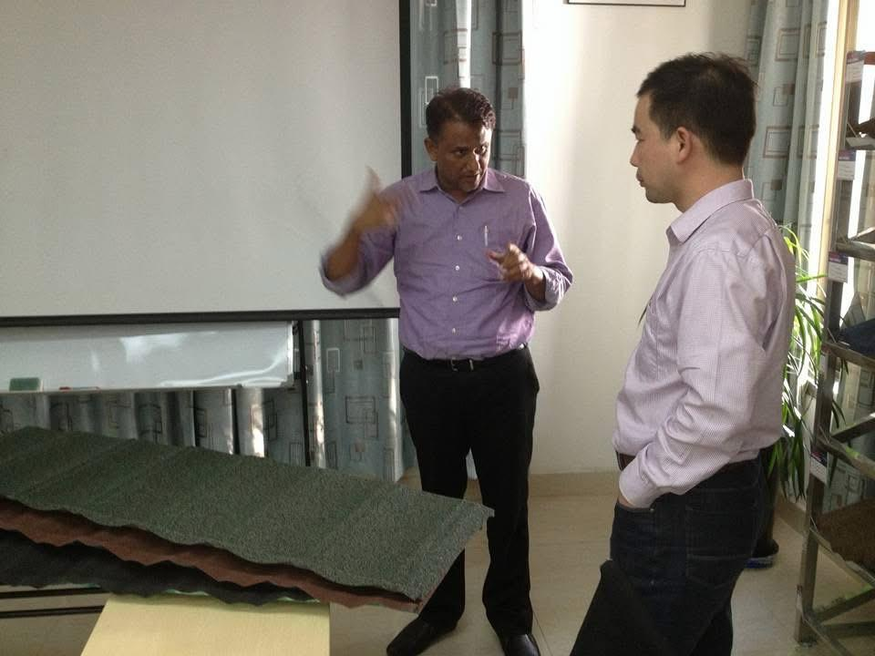
Our MD Mr.Rahim Iyaz in a China factory visit in 2015

Import with Ease

One Stop Shop
- End to end import assistance to source, negotiate, quality control, inspect and deliver from China & globally

Trend Analysis
- We can also help you to choose the right market by analyzing your strengths and the prevailing business trends.

Travel Support
- We support your China visit with visa and ticketing formalities, hotel bookings, Indian food & arranging translators to take you to the desired markets.

Right Supplier Sourcing
- A lot can go wrong if you end up sourcing a wrong supplier. We help you to identify your products, negotiate with the right manufacturers with the help of our local intelligence cell in China. We can reduce your purchase cost by 30% - 40% minimum.

After Order Placement Support
- Once the ordered goods are ready for dispatch; we inspect the goods, re-pack it and book the vessels and facilitate the shipping to the destined country.

Customs Clearance
- Being a licensed Customs Broker, we facilitate the Customs clearance in India and do all the necessary arrangements to deliver the goods at your door steps.

LCL Cargo Facility
- Besides FCL (Full Container Load), we can also help to source and deliver the goods on your behalf by a smaller quantity of LCL (Lesser than a Container Load) Cargo facility.

Hassle Free Import
- You import hassle free as your job ends with finalizing the products; all other formalities are taken care of by us.

Utmost Transparency
- We strongly believe in transparent dealings, we don't collect any hidden charges. We are a professional co-ordinator helping you in the process; and we only take agreed service charges.

Visit Canton Fair
Canton Fair is the largest Bi-annual China Trade Fair (April & October) held in Guangzhou, wherein all the leading Chinese manufacturers would exhibit their products.

It's no wonder that the Canton Fair has already become a must see for all those looking for business success in China. It is the most effective way to develop a business relationship.

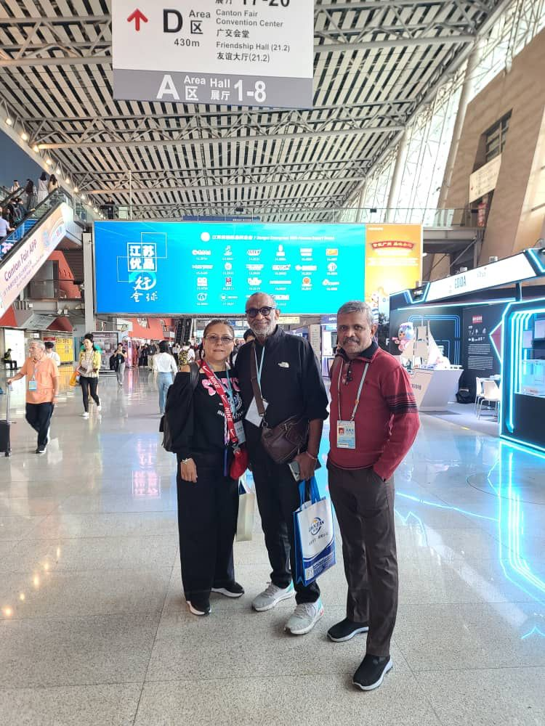
Our China Incharge Mr.Azeez with our USA Clients at Canton Fair, 2025.

CANTON FAIR DETAILS

Phase 1

Electronics & Appliance
Household Electrical Appliances, Consumer Electronics and Information Products

Manufacturing
Industrial Automation and Intelligent Manufacturing, Processing Machinery Equipment, Power Machinery and Electric Power,General Machinery and Mechanical Basic Parts, Construction Machinery, Agricultural Machinery,New Materials and Chemical Products.

Vehicles & Two Wheels
New Energy Vehicles and Smart Mobility,Vehicles, Vehicle Spare Parts, Motorcycles,Bicycles

Light & Electrical
Lighting Equipment,Electronic and Electrical Products, New Energy Resources

Hardware
Hardware,Tools

Phase 2

Houseware
General Ceramics, Kitchenware and Tableware, Household Items.

Gift & Decorations
Glass Artware, Home Decorations, Gardening Products, Festival Products, Gifts and Premiums, Clocks, Watches and Optical Instruments, Art Ceramics, Weaving, Rattan and
Iron Products.

Building & Furniture
Building and Decorative Materials, Sanitary and Bathroom Equipment, Furniture, Stone/Iron Decoration and Outdoor Spa Equipment.

Phase 3

Toys & Children Baby and Maternity
Toys, Children, Baby and Maternity Products, Kids' Wear.

Fashion
Men and Women's Clothing, Underwear, Sports and Casual Wear, Furs, Leather, Downs and Related Products, Fashion Accessories and Fittings, Textile Raw Materials and Fabrics，Shoes, Cases and Bags.

Home Textiles
Home Textiles, Carpets and Tapestries.

Stationery
Office Supplies

Health & Recreation
Medicines, Health Products and Medical Devices, Food,Sports, Travel and Recreation Products, Personal Care Products, Toiletries, Pet Products and Food.

Canton Fair Official Website: https://www.cantonfair.org.cn/

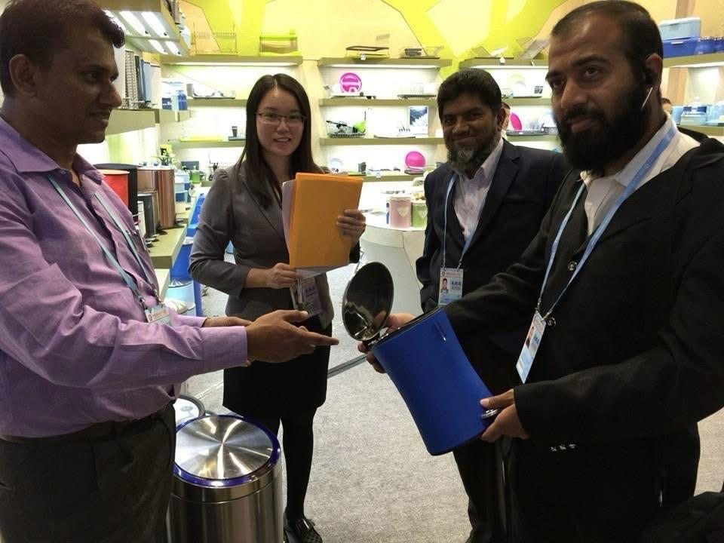
Our MD Mr. Rahim Iyaz with Mr.Riaz, MD of King’s Group of Companies and Mr.Malik of Tirunelveli at China Canton Fair in 2014

CHINA CANTON FAIR SERVICES:

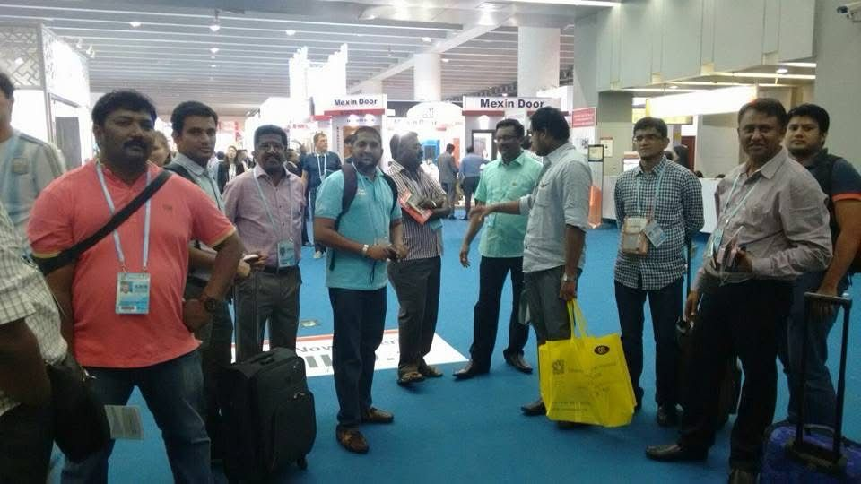
Canton Fair group with Indian Clients in 2015

We arrange China Trade Fair packages for individuals and groups during every season as per the specified category.

- Assistance of visa & tickets formalities
- Airport pick up & drop in China
- Hotel single / twin sharing
- Indian food / Turkish / Arabian gala dinner
- Local transportation
- Markets & factories visits with Chinese guide
- Local sightseeing & shopping
- Trade consultancy
Personalized Services in China

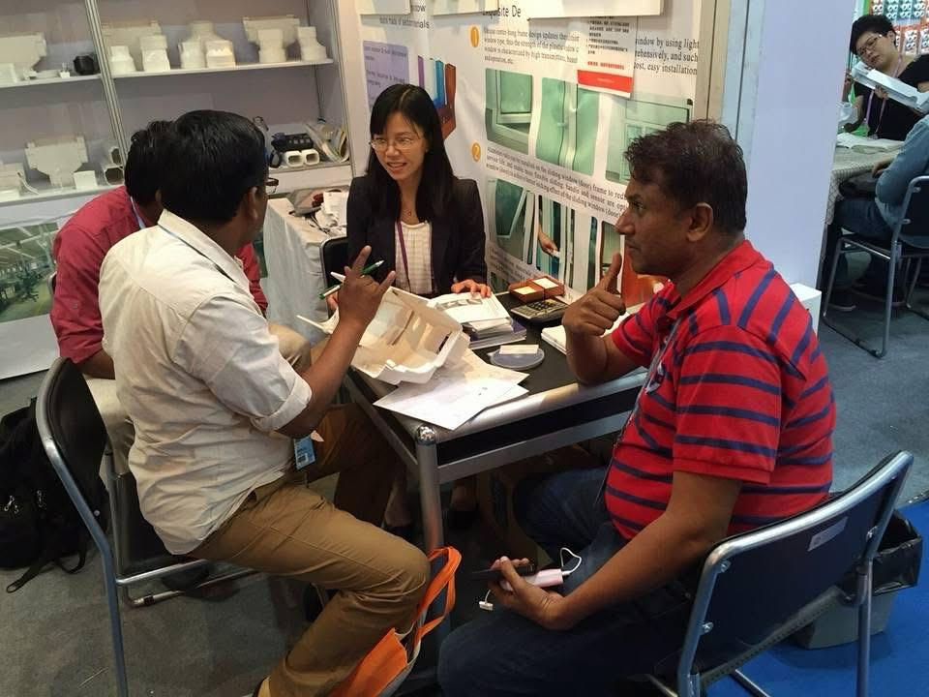
China sourcing at Canton Fair in 2015

- Specialist in Architects designed life-style products
- Permanent staffing with multilingual negotiating skills
- Trade analysis to choose the right products
- Hassle free FCL / LCL cargo facilities
- Factory / cargo inspection
- Utmost transparency with service charge module
- Minimum 30% profit guaranteed on purchase
- Product Replacement Warranty*
- Travel support to Canton Fair services
- 12x7 after sales services in China and India

4. Licensed Customs Broker
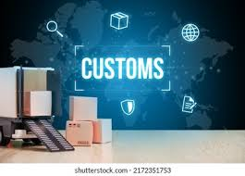
Picture source: Google
Government authorised Clearing Agent
We act as an agent on behalf of importers and exporters; for the clearance of imported or export goods under the provisions of the Customs Brokers Regulations, 2018.
Licensed Customs Broker
As per Customs Brokers Licensing Regulations 2018, under Regulation 2(d), "Customs Broker " means a person licensed under these regulations to act as an agent on behalf of the importer or an exporter for purposes of transaction of any business relating to the entry or departure of conveyances or the import or export of goods at any Customs Station including audit.
How We Work?
- Prior to engagement of our services, we do obtain an authorisation to act as an Agent for the clearance of your imported or export goods.
- We clear your goods in all Customs Stations across India; with our Pan India network.
- We advise our clients to comply with the provisions of The Customs Act, The Customs Tariff Act, Foreign Trade Policy, Allied Acts, Rules, Regulations and Orders.
- We exercise due diligence to ascertain the correctness of any information related to clearance of your shipments.
- We discharge our duties as a Customs Broker with utmost speed and efficiency and without any delay.
- We co-operate with the Customs authorities and PGAs; for the speedy clearance of your cargo.

5, Export - Import Clearance
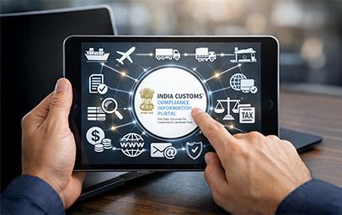
Picture source: https://www.icegate.gov.in/
EXIM clearance with Compulsory Compliance Requirements (CCR)
Customs Compliance is a structured legal obligation under the Customs Law and other Allied Acts; wherein the importer / exporter produces required documents to the authorities for the smooth clearance of the goods. Absence of even one requirement may lead to penalties, cargo delays or even seizure of goods.
↓
We ensure proper documentary compliance for hassle free clearance of the cargo.

1. Customs Documentation
We prepare and file:
- Bill of Entry for Home Consumption or Warehousing (for Imports)
- Shipping Bill / Bill of Export (for Exports)
- Invoice, Packing List, Bill of Lading / Airway Bill
- Import Export Authorisations and Certificates
- GST / IEC related paperwork

2. Customs Clearance
We coordinate with the Customs Authorities to:
- Submit declarations electronically
- Respond to customs queries
- Arrange inspections / examinations
- Obtain clearance for smooth cargo release

3. Duty & Tax Calculation
We help to calculate:
- Correct HS Code Classification
- Basic Customs Duty (BCD)
- Additional Customs Duty / Special Additional Customs Duty (for manufactured goods)
- IGST / GST Compensation Cess
- Preferential Duty / Duty under Trade Agreements
- Export Duty
- Safeguard Duty
- Countervailing duty on subsidized articles
- Anti-Dumping Duty (ADD)
- Social Welfare Surcharge (SWS)
- Agricultural Infrastructure Development Cess (AIDC)
- Other applicable taxes

4. Compliance & Regulations

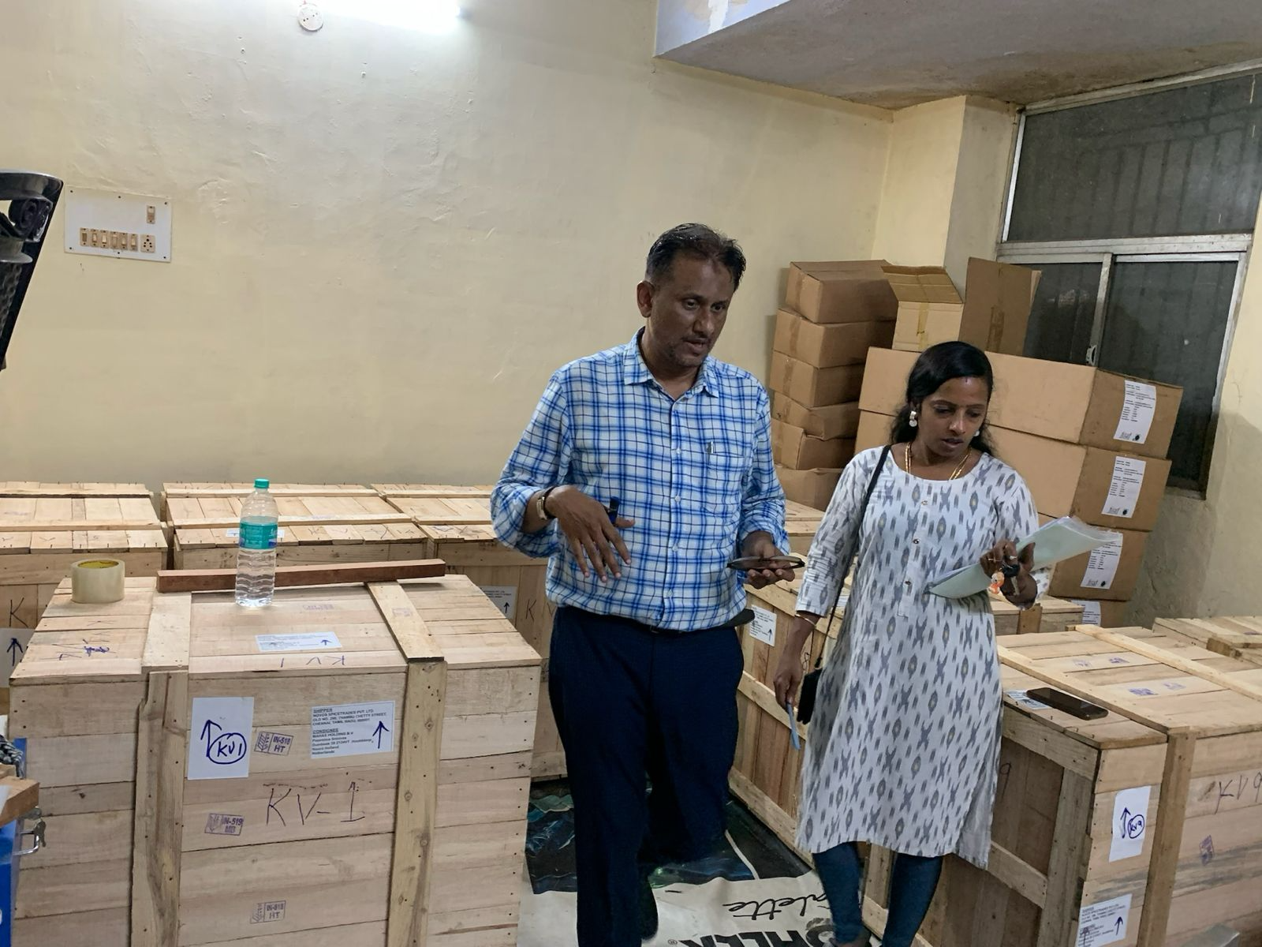
Product inspection of Hotel supplies shipment to Netherlands in 2024

We ensure your shipments to comply with the provisions of:
- The Customs Act / The Customs Tariff Act
- FTDRA / FTRR / FTP / HBP Compliances
- RBI / FEMA Regulations
- FSSAI, BIS, CDSCO, Plant Quarantine, etc. (depending on the product type)

5. Port & Cargo Coordination
We coordinate with:
- Shipping Lines / Airlines
- Port Authorities
- Container Freight Stations (CFS)
- Inland Container Depots (ICD)
- Logistics providers
6. Cargo Delivery Support
After Customs Clearance, we help to arrange:
- Container movement
- Last-mile transportation
- Warehousing
- Delivery Order

7. Advisory Services
We also advise on:
- Duty Savings Schemes
- Free Trade Agreements (FTA)
- MOOWR / EPCG / Advance Authorization
- EOU / SEZ / EHTP / STP / BTP
- Export Incentives
- Customs Audits and Disputes
Our Import Workflow Process
For eg: If you import machinery from China into Chennai Port:
- We receive shipping documents from the Importer
- Files Bill of Entry in ICEGATE
- Calculates Customs duties
- Coordinates Customs inspection
- Advise importer in the payment of duty
- Gets cargo released by obtaining OoC
- Arranges transport to the Importer’s warehouse
Our Export Workflow Process
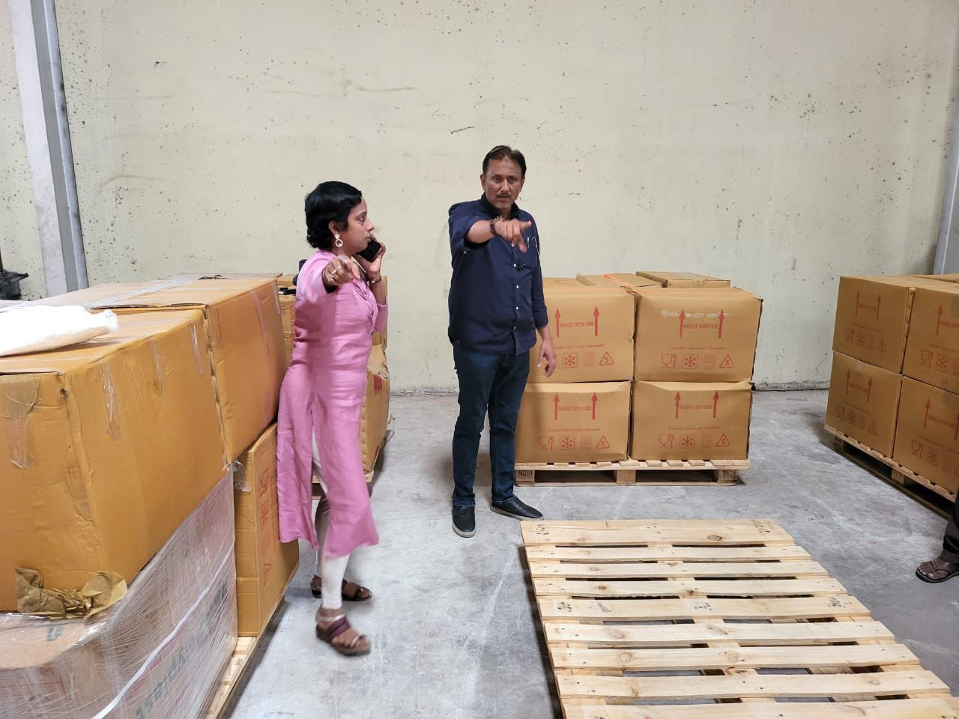
Inspection of export shipment to USA in 2025
- Collection of Export Documents
(Invoice, Packing List, PO, LUT/Bond, etc.)
- HS Code Classification & Compliance Check
- Shipping Bill Preparation in ICEGATE
- Customs Duty / Scheme Verification
(Duty Drawback, RoDTEP, RoSCTL, EPCG, Advance Authorization, etc.)
- Cargo stuffing
- Transportation to CFS or ICD / Port or Airport
- Customs Assessment / Examination
- LEO (Let Export Order) approval
- Container Loading / Airline Handover
- Bill of Lading / Airway Bill generation
- Vessel departure / Flight departure procedures
- Guidance in submission of export documents to the bank
- Export Incentive / Compliance follow-up
- Payment follow-ups
- Proof of export & record maintenance
6. Freight Forwarding & Logistics
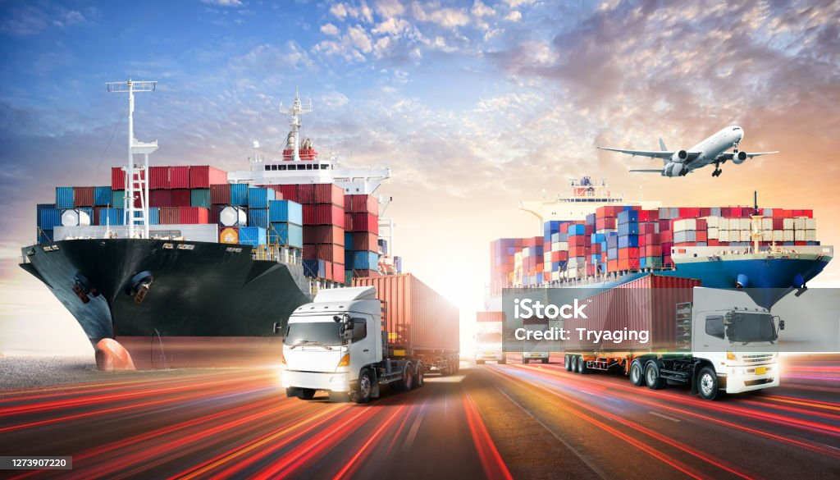
Efficient movement and storage of goods
Logistics refers to the planning, coordination, and movement of goods from the point of origin to the final destination. It is a key part of Supply Chain Management, ensuring that products are delivered efficiently, on time, and in the right condition.
↓
PORTMATRIX provides logistics services which include transportation (by road, air, sea, or rail), cargo consoling, warehousing, inventory management, packaging, and distribution.

Freight forwarding is the professional management of moving goods from origin to destination by sea, air, road, or rail, including transportation, documentation, customs, storage, and delivery.
As a Logistics Coordinator, we support:
- Exporters & Importers
- Shipping Lines & Airlines
- Transporters
- Customs Authorities
- Warehouses
Our Core Freight Forwarding Services:
- Ocean & Air Freight
- Postal Export
- E-Commerce Export
- Warehousing & Distribution
- Transportation & Last-Mile Delivery
- Cargo Consolidation
- Documentation & Trade Compliance
- Marine Insurance
- Supply Chain Management
We coordinate the complete movement of cargo—ensuring it reaches the right place, at the right time, with the right documentation and compliance.
Our Logistics Business Segments
Segment | Description
Freight Forwarding | Managing cargo movement internationally
Customs Brokerage | Customs Documentation & Clearance
Warehousing | Storage and inventory management
Transportation | Trucking and inland movement
3PL (Third-Party Logistics) | End-to-end logistics outsourcing
4PL Logistics | Full supply chain management
Cold Chain Logistics | Temperature-controlled logistics
E-commerce Logistics | Fulfillment and delivery solutions

Freight Forwarding Workflow
Customer confirms shipment
↓
Cargo pickup arranged
↓
Documentation prepared
↓
Customs clearance completed
↓
Cargo booked with carrier
↓
Shipment moved via air / sea / road
↓
Destination customs clearance
↓
Final delivery to consignee

Key Documents Used:
- Commercial Invoice
- Packing List
- Bill of Lading (BL) / Air Waybill (AWB)
- Shipping Bill
- Certificate of Origin
- Insurance Certificate
- Delivery Order (DO)

7. MSME Insurance Package

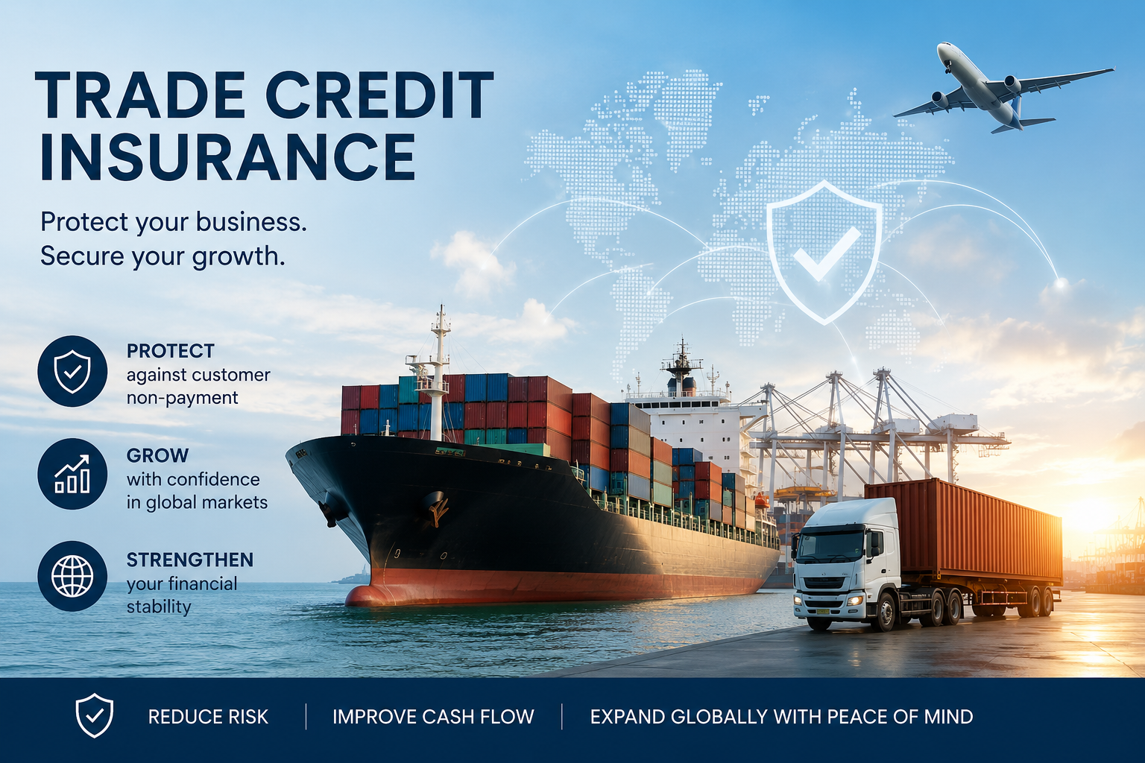
Shield your trade!

Affordable protection for your business, assets, and operations against unforeseen risks.
↓
We assure your trade by facilitating MSME Insurance for:
- Exporters
- Local Traders & wholesalers
- Indian Manufacturers
- Indian Logistics / freight forwarders offering credit in their business

Following SME Trade Insurance products are available in the market:

- Export Credit Insurance
- Domestic Trade Credit Insurance
- Political Risk Insurance
- Factoring
- Forfaiting
- Marine Cargo Insurance
- Marine Hull Insurance
- Inland Transit Insurance
- Warehousing Insurance
- Warehouse Keeper’s Liability Insurance
- Port & Terminal Operators Policy
- Freight Services Liability Insurance Policy
- Duty Transit Insurance
- SME Directors & Officers Liability Insurance
- Key Man Insurance

Export Credit Insurance:
- Export Credit Insurance (ECI) protects exporters against the risk of non-payment by overseas buyers. It’s one of the most important financial safeguards for Indian exporters.

Domestic Trade Credit Insurance:
- Domestic Trade Credit Insurance (DTCI) protects Indian businesses against non-payment by buyers within India when you sell on credit terms (e.g., 30–90 days).
Coverage includes protection against buyer default, insolvency, and delayed payments.

Political Risk Insurance:
- Political Risk Insurance (PRI) protects businesses against losses caused by government actions or political events in a foreign country—something standard insurance usually won’t cover.

Key difference from credit insurance
Feature | Credit Insurance | Political Risk Insurance
Covers | Buyer default | Government / political events
Scope | Commercial risk | Sovereign risk
Usage | Trade | Investment + trade

Factoring:
- Factoring is a financing method where a business sells its accounts receivables (invoices) to a third party (factor) to get immediate cash, instead of waiting 30–90 days for customer payment.

Forfaiting
- Forfaiting is a specialized form of export financing where exporters sell their receivables (usually medium- to long-term) to a forfaiter at a discount, on a “without recourse” basis—meaning the risk of non-payment is transferred to the forfaiter.
- Forfaiting is mainly used in international trade, especially for capital goods exports or large-value shipments.
Forfaiting vs Factoring
Aspect | Forfaiting | Factoring
Tenure | Medium/Long-term | Short-term
With Recourse  "With Recourse" means the seller or borrower remains liable if a debt is unpaid, allowing the creditor to pursue them directly. | Without Recourse  "Without Recourse" means the creditor takes on all risk, with no legal recourse to seize personal assets beyond specific collateral. | Can be with / without recourse
Coverage | Export (mainly capital goods) | Domestic & Export
Instruments | Bills of Exchange, Promissory Notes | Invoices

Marine Cargo Insurance:
- Marine Cargo Insurance is one of the most essential covers for anyone involved in logistics, imports, or exports—it protects goods while they are in transit by sea, air, rail, or road.

Marine Hull Insurance:
- This is a type of marine insurance that provides coverage for physical loss or damage to a vessel's hull, machinery, equipment, and fittings caused by marine perils.

Inland Transit Insurance:
Inland transit insurance, also known as inland marine insurance, refers to a kind of insurance whereby the insured goods or properties are protected while in transit via road transport, rail transport, or inland water transport.

Warehousing Insurance:
Warehousing insurance protects goods stored in a warehouse against loss or damage due to fire, theft, natural disasters, and handling risks. In India, it’s not a single fixed policy—it's usually structured using a combination of standard insurance products depending on your business model.

Warehousing Insurance is not a single policy—it’s a combination of covers designed to protect:
- the warehouse building,
- the goods stored, and
- your liability (if goods belong to customers).

Warehouse Keeper’s Liability Insurance:
- Warehouse Keeper’s Liability Insurance (WKLI) is essential if you store goods belonging to others—it protects you when you’re legally responsible for loss or damage to those goods while in your care.

Port & Terminal Operators Liability Insurance:
- This is a specialized insurance policy designed to protect port authorities, terminal operators, stevedores, container freight stations, inland container depots, and logistics operators against legal liabilities arising from their port and terminal operations.

Freight Services Liability Insurance:
- This protects Freight Forwarders, Logistics Operators, Customs Brokers, Multimodal Transport Operators, and NVOCCs against legal liabilities arising from the transportation, handling, storage, and forwarding of cargo.

Duty Transit Insurance:
- A single integrated policy covering customs duty, safe cargo transit, and insurance protection, ensuring compliant movement of goods and financial protection against transit-related risks.
Directors & Officers (D&O) Liability Insurance:
- This insurance protects the Directors, Officers, and Key Management Personnel of a company against claims arising from alleged wrongful acts committed while performing their managerial duties.

Keyman Insurance:
- This is a life insurance policy that a business purchases on a Critical Employee, Owner, Founder, or Executive whose loss would significantly affect the company. The business pays the premiums, owns the policy, and receives the insurance payout if the insured person dies (and sometimes if they become disabled, depending on coverage).

8. MOOWR
Manufacture and Other Operations in Warehouse Regulations
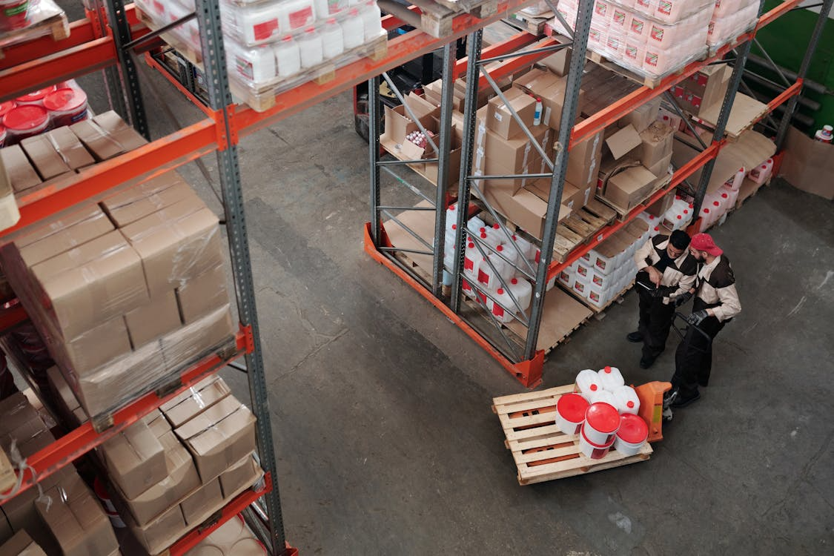
Picture source: ChatGPT
Import without payment of Duty / IGST
MOOWR or Section 65 Warehousing Unit is a powerful scheme that allows the manufacturers to import raw materials and capital goods without paying customs duty upfront. It can be stored in a bonded warehouse; and to carry out manufacturing or other operations.
↓
We facilitate the registration of MOOWR License.

MOOWR Warehousing

MOOWR stands for Manufacture and Other Operations in Warehouse Regulations, 2019 under the Indian Customs framework. It allows companies to operate manufacturing, assembly, processing, packaging, testing, or other operations inside a bonded warehouse without upfront customs duty payment.
Under Section 65 of The Customs Act 1962, companies can convert their factory or warehouse into a Private Bonded Warehouse. The imported goods can be stored and used without immediate payment of:
- Basic Customs Duty (BCD)
- IGST
- Social Welfare Surcharge
- Certain additional duties
Duties are paid only when goods are cleared into the domestic market. Exported goods generally remain duty-free.
Key Benefits of MOOWR Warehousing

1. Duty Deferment
Import raw materials and capital goods without upfront customs duty payment.

2. No Export Obligation
Unlike SEZ, Advance Authorisation or EPCG, there is no mandatory export commitment. Goods can be sold in India as well.

3. Better Cash Flow
Since duties are deferred; hence working capital requirements reduce significantly.

4. No Time Limit for Storage
Imported capital goods and inputs can remain in the bonded warehouse without strict time restrictions.

5. Suitable for Domestic & Export Businesses
The scheme benefits:
- Manufacturers
- Importers / Exporters
MOOWR Scheme Flow Chart
Apply for Private Warehousing License U/S 58 and MOOWR License U/S 65 simultaneously with the guidance of PORTMATRIX
↓
Import Goods
↓
Store in MOOWR Warehouse
↓
Manufacture / Process
↓
- Sell in India → Duty payable at the time of clearance
- Export finished goods → No Customs duty

Types of Operations Allowed in MOOWR
Inside a MOOWR Warehouse, businesses can perform:
- Manufacturing
- Assembly
- Packaging
- Labeling
- Testing
- Repairing
- Reconditioning
- Processing

Eligibility
Any Indian entity can apply if:
- It has a warehouse facility
- It obtains:
  - Section 58 - Warehouse license
  - Section 65 - Manufacturing permission
Existing factories can also be converted into MOOWR units.
MOOWR vs SEZ vs EPCG
Feature | MOOWR | SEZ | AA / EPCG
Export Obligation | No | Yes | Yes
Domestic Sales Allowed | Yes | Restricted | Restricted
Duty | Deferred | Excempted | Excempted
Capital Goods Coverage | Yes | Yes | Yes
Location Restriction | No | Yes | No
GST Benefits | Limited | Strong | Limited

Warehousing Compliance Requirements
MOOWR units must maintain:
- Digital inventory records
- Customs audit trail
- Monthly returns
- Bond execution
- Warehouse security controls
Customs authorities supervise compliance periodically.
9. ⁠Advance Authorisation Scheme


Picture source: ChatGPT
Duty free import of raw materials
It is a duty exemption scheme by DGFT; that enables duty free import of raw materials for export production.
↓
PORTMATRIX guides the exporters to register Advance Authorisation (AA) and Duty Free Import Authorisation (DFIA) on post export.
The Advance Authorisation Scheme (AAS) is an export incentive program promoted by the Ministry of Commerce and Industries; to encourage exports by reducing input costs for manufacturers.
Advance Authorisation Scheme
The Advance Authorisation Scheme allows exporters to import raw materials, components, or inputs duty-free (i.e., without paying customs duties), provided those inputs are used to produce goods that will be exported.
🔹 Key Features
Duty-free import of inputs such as:
- Raw materials
- Intermediate goods
- Packaging materials
- Fuel (in some cases)
Export obligation
- The importer must export finished goods using those inputs within a specified time frame.
- Value addition requirement
- Exported goods must have a minimum value addition over imported inputs (e.g. typically around 15%, though it can vary).
Wide applicability
- Manufacturer exporters
- Merchant exporters tied to supporting manufacturers
🔹 Types of Advance Authorisation
Physical Exports
- Goods are physically exported out of the country.
Deemed Exports
- Supplies to units like EOU, EHTP, STP, BTP are treated as exports.
Annual Requirement Authorisation
- For exporters with regular production needs.
🔹 Benefits
- Reduces production cost → increases global competitiveness
- Improves cash flow (no upfront duty payment)
- Encourages higher export volumes
🔹 Conditions & Compliance
- Must maintain detailed records of input usage
- Must fulfill Export Obligation within deadline
Subject to audit by authorities like the Directorate General of Foreign Trade (DGFT)
🔹 Simple Example
A textile exporter imports fabric duty-free under AAS → uses it to manufacture garments → exports garments → fulfills Export Obligation → no duty payable.
Advance Authorisation Scheme – Flow Chart
Exporter receives Export Order
↓
Estimate Raw Materials / Inputs Required
↓
Apply for Advance Authorisation to DGFT with the guidance of PORTMATRIX
↓
DGFT Issues Advance Authorisation License
↓
Import Inputs / Raw Materials Duty-Free
↓
Manufacture the Finished Goods
↓
Export the Finished Goods
↓
Submit Export Proof & Documents
↓
Fulfil Export Obligation
↓
Redemption / Closure of Authorisation

Key Authorities Involved
- Directorate General of Foreign Trade (DGFT)
- Central Board of Indirect Taxes and Customs (CBIC)

Common Documents
- Import Invoice
- Bill of Entry
- Shipping Bill
- Export Invoice
- e-BRC (Bank Realisation Certificate)
10. Export Promotion Capital Goods (EPCG) Scheme

Picture source: https://www.pexels.com/search/machine/
Duty free import of Capital Goods
This Scheme is to facilitate import of capital goods at zero customs duty and other taxes; for producing quality goods and services to enhance India’s manufacturing competitiveness to boost export capability.
↓
PORTMATRIX facilitates exporters to avail EPCG License.
Export Promotion Capital Goods (EPCG) Scheme
The Export Promotion Capital Goods (EPCG) Scheme is a foreign trade incentive scheme under India’s Foreign Trade Policy (FTP). It allows import of capital goods at zero customs duty for producing goods or services meant for export.
Objective
To help Indian exporters modernize technology and improve export competitiveness by reducing the cost of importing machinery and equipment.
Key Features
Import of capital goods at concessional/zero customs duty
Applicable for:
- Manufacturers
- Exporters
- Service providers
Supports:
- Machinery
- Equipment
- Spares
- Tools
- Computer systems
Export obligation must be fulfilled within a specified period) usually 6 years + 2 years extensions may be provided).
EPCG Scheme Flow Chart
Apply for EPCG Authorization with the guidance of PORTMATRIX
↓
Import Capital Goods at Zero Duty
↓
Install & Use Machinery
↓
Manufacture Goods / Provide Services
↓
Export Products or Services
↓
Fulfill Export Obligation
↓
Submit Documents to DGFT & Customs
↓
EPCG Authorization Closed
Benefits
- Reduces machinery import cost
- Improves manufacturing capability
- Encourages exports
- Enhances global competitiveness
- Helps technology upgradation
Example
A company imports a machine worth ₹1 crore under EPCG and saves ₹7.50 lakh duty.
The company must achieve 6 times the amount of duty saved, in a period of next 6 years.
Export Obligation is : ₹ 7.50 lakh x 6 times = ₹ 45 lakh.
Related Authorities
- Directorate General of Foreign Trade
- Central Board of Indirect Taxes and Customs

11. Special Economic Zone (SEZ)

Picture source: https://sezindia.gov.in/photo-gallery

Duty free enclave for MSMEs

SEZ is a specifically demarcated region where business and trade laws are more liberal compared to the rest of the country. The goal is to attract foreign investment, boost exports, and generate employment. SEZ Companies enjoy tax benefits, simplified regulations, world-class infrastructure, duty free imports / exports.
↓
PORTMATRIX assists in the registration of SEZs.
Special Economic Zone (SEZ)
SEZ is a specially designated duty-free area treated as foreign territory for trade operations, duties, and tariffs. SEZs are established to promote exports, attract investment, create jobs, and develop infrastructure. SEZ framework is governed by the SEZ Act, 2005 and SEZ Rules, 2006.
Simple Definition
SEZ = Duty-free Business Zone created to promote exports and investment.
Main Features of SEZs
- Duty-free import / procurement of goods for development and operations
- Simplified customs and compliance procedures
- Income tax and GST-related benefits (subject to current regulations)
- 100% Foreign Direct Investment (FDI) allowed in many sectors
- Single-window clearance mechanism
- Better infrastructure and logistics support
Objectives of SEZs
- Promote exports of goods and services
- Attract domestic and foreign investments
- Generate employment opportunities
- Develop world-class infrastructure
- Enhance India's global trade competitiveness
Types of SEZs
- Multi-Product SEZ – Multiple industries and sectors
- Sector-Specific SEZ – Dedicated to one industry (IT, Pharma, Textiles, etc.)
- Free Trade & Warehousing Zone (FTWZ) – Trading, warehousing, logistics activities
Major SEZ in Tamil Nadu
Mahindra World City - Tamil Nadu - IT & Manufacturing
Benefits for Businesses
- Customs duty exemptions
- Faster import /export processing
- Improved warehousing and logistics
- Better global supply chain connectivity
- Export-oriented growth opportunities
Authority: Department of Commerce – SEZ India

12. Free Trade Warehousing Zone (FTWZ)
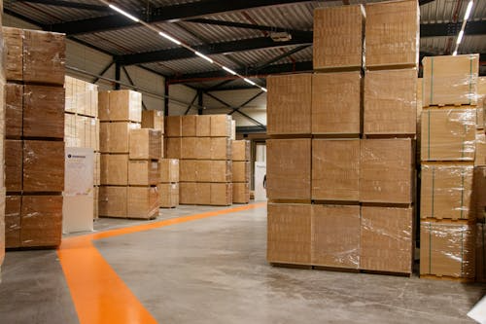
Picture source: https://www.pexels.com/search/free%20trade%20warehousing%20zone/
Duty free trading hub for MNCs
FTWZ is a special category of Special Economic Zone (SEZ) designed mainly for trading and warehousing of goods. This allows businesses to delay or avoid duty, improving cash flow and flexibility.
↓
PORTMATRIX supports FTWZ registration.
Free Trade Warehousing Zone (FTWZ)
A Free Trade Warehousing Zone (FTWZ) is a special category of Special Economic Zone focused on warehousing, trading, logistics, and re-export activities. FTWZs are treated as foreign territory for customs purposes, allowing goods to be imported, stored, processed, and re-exported with major duty and tax advantages.

Simple Definition:
FTWZ is a duty-free logistics and warehousing zone that facilitates international trade, storage, and re-export operations in India.
Key Features of FTWZ
- Duty-free storage of imported goods
- Customs duty paid only when goods enter the Indian market (DTA)
- Re-export without customs duty
Value-added services allowed:
- Labeling
- Repacking
- Kitting
- Assembly
- Palletization
- Faster customs clearance
- Foreign currency transactions permitted
- Treated as foreign territory under customs law
FTWZ Scheme Workflow
Foreign Supplier
↓
Import into FTWZ with the guidance of PORTMATRIX
↓
Duty-free Storage
↓
Value Addition / Packaging / Labeling
↓
┌─────────────────────┐
↓ ↓
Re-export Sale in India
(No duty) (Duty paid only at clearance)

Benefits of FTWZ
For Importers:
- Deferred customs duty
- Reduced working capital blockage
- Faster supply chain movement
- Lower port demurrage costs
For Exporters:
- Re-export without import duty (Merchant Trade Transactions-MTT)
- Export benefits available
- Long-term storage flexibility
For Global Traders:
- No permanent establishment required in some cases
- Foreign suppliers can store inventory in India
- Multiple ownership transfers allowed within FTWZ
Activities Allowed in FTWZ
- Warehousing
- Trading
- Re-export
- Packaging & repackaging
- Relabeling
- Assembly of kits
- Quality inspection
- Refrigerated storage
- Inventory management
FTWZ Legal Framework in India
FTWZs are governed under:
- Ministry of Commerce and Industry
- Special Economic Zones Act 2005
- SEZ Rules 2006
- Foreign Trade Policy (FTP)
Major FTWZ in Tamil Nadu
State | Location | Developer
Tamil Nadu | Sriperumbudur | J Matadee FTWZ

Difference Between SEZ and FTWZ
SEZ | FTWZ
Manufacturing & services focus | Warehousing & Trading Focus
Export production | Import / Export Storage & Distribution
Industrial Operations | Logistics & Supply Chain Operations
Broader Economic Zone | Specialized Logistics Zone

13. EOU (Export Oriented Unit)
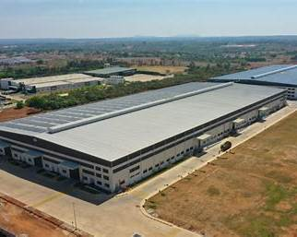
Export Goods Manufacturing Hub
An Export Oriented Unit (EOU) is a business unit approved by the Government of India that undertakes to export its entire production of goods or services, except for permitted sales in the Domestic Tariff Area (DTA).
↓
PORTMATRIX supports in the registration process of EOUs
Key Objectives
- Promote exports from India
- Earn foreign exchange
- Generate employment
- Encourage investment and technology development
- Enhance India's global trade competitiveness

Eligible Activities
EOUs can be established for:
- Manufacturing
- Service exports
- Software development
- Repair, reconditioning, and re-engineering
- Gems & jewellery
- Agriculture and agro-processing
- Biotechnology
- Aquaculture, poultry, horticulture, floriculture, etc.

Major Benefits of EOU
- Duty-free import of raw materials and capital goods
- Duty-free procurement from domestic suppliers
- GST-related benefits and refunds as applicable
- Faster customs clearances
- 100% FDI permitted in many sectors
- Can be established anywhere in India (unlike SEZs, which are location-specific)

Basic Eligibility
- Primarily Export-Oriented operations
- Positive Net Foreign Exchange (NFE) earnings over the prescribed period
- Generally, minimum investment of ₹1 crore in plant and machinery (with exemptions for sectors such as IT, biotechnology, handicrafts, and agriculture)
- Trading activities are generally not permitted under the EOU scheme.

EOU Approval Process
- Incorporate the business entity.
- Obtain PAN, GST, and IEC.
- Apply through the Development Commissioner.
- Obtain Letter of Permission (LoP).
- Execute customs bonding (B-17 Bond).
- Start operations and maintain export obligations and compliance requirements

14. Authorised Economic Operator (AEO)

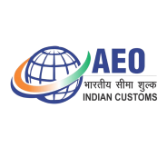
Picture source: https://aeoindia.gov.in/index

Global Certification for secure, compliant and efficient Customs processes
It is a flagship trade facilitation initiative under the World Customs Organization. It recognizes international businesses with faster customs clearance, reduced inspections and examinations, duty deferment privilege, Direct Port Delivery (DPD) / Direct Port Entry (DPE), Priority processing of consignments.
↓
We support in facilitating the procedures for obtaining AEO status.

Authorised Economic Operator (AEO)
The Central Board of Indirect Taxes and Customs (CBIC) introduced the Indian AEO Programme to promote secure and faster international trade. It is based on the World Customs Organization SAFE Framework standards.

Simple Definition
AEO = Trusted International Trade Partner certified by Customs.

What is AEO?
This is a business entity involved in international trade that is recognized by the Customs as a trusted and compliant trade partner.
AEO-certified entities receive customs facilitation benefits such as:
- Secure supply chain
- Credibility with the international partners
- Faster customs clearance
- Reduced cargo inspections
- Priority processing
- Deferred duty payment
- Direct Port Delivery (DPD) / Direct Port Entry (DPE)
- Lower transaction costs
- International recognition under Mutual Recognition Agreements (MRAs)
- Waiver of full or part of the Bank Guarantee requirements /f Merchant overtime fees

Who Can Apply?
The AEO programme covers entities in the international supply chain, including:
- Importers
- Exporters
- Customs Brokers
- Logistics Providers
- Freight Forwarders
- Warehouse Operators
- Port Operators
- Terminal Operators
AEO Categories in India
Category | Applicable To | Level | Validity
AEO-T1 | Importers / Exporters | Entry level | 3 Years
AEO-T2 | Importers / Exporters | Advanced | 3 Years
AEO-T3 | Importers / Exporters | Highest accreditation | 5 Years
AEO-LO | Logistics Providers, Custodians or Terminal  Operators, Customs Brokers and  Warehouse Operators | Logistics category | 5 Years

Major Benefits

For Importers & Exporters
- Faster release of cargo
- Reduced examination percentage
- Priority assessment
- Deferred duty payment
- Self-certified copies accepted
- Fewer document verifications

For Customs Brokers & Logistics Operators
- Priority movement of consignments
- Better global credibility
- Improved client confidence
- Reduced delays in supply chain operations

Basic Eligibility
An applicant generally should have:
- Good compliance record
- Financial solvency
- Secure supply chain processes
- Proper internal controls
- Minimum business activity period (as prescribed by CBIC)

Application Process
- Self-assessment of eligibility
- Online registration on AEO portal
- Submission of application & documents
- Customs verification / audit
- Approval and grant of certification
Official portal: AEO India Portal

Importance of AEO in India
The AEO programme supports:
- Ease of Doing Business
- Secure global supply chains
- Faster exports and imports
- Reduced logistics cost
- Trusted trader ecosystem
India’s AEO programme is aligned with the WTO Trade Facilitation Agreement (TFA).

15. NRI Baggage Clearance
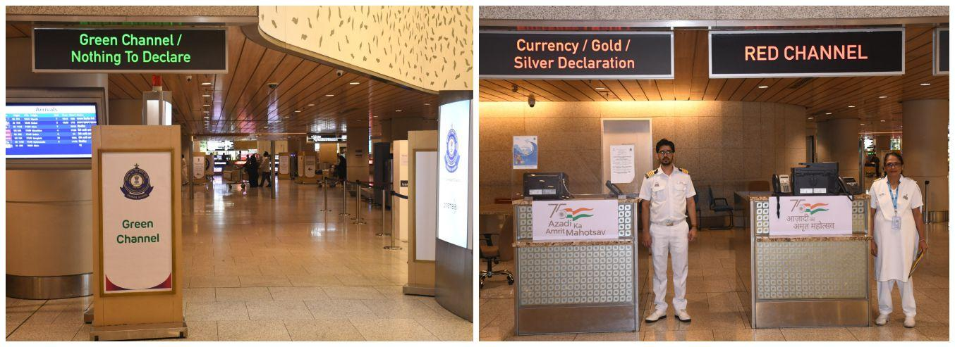Clearance of your baggage with ease
Baggage refers to personal belongings, travel articles, and other goods carried by passengers while entering or leaving India. Baggage includes unaccompanied baggage and excludes motor vehicles. Passengers arriving in India are allowed to bring bonafide (used personal effects) and specified goods; free of customs duty within prescribed limits.
↓
PORTMATRIX advises the NRI Clients in proper declaration of their baggage clearance in India; without payment of duty as per The Baggage Rules, 2026.

Baggage Clearance
Every passenger entering India has to pass through a Customs check after first being cleared by an immigration Officer and taking delivery of his / her baggage, if any, from the conveyor belts. The passenger has the option of seeking Customs clearance through either of the two channels: a) Green Channel b) Red Channel. When the passenger chooses Green Channel, it is deemed to be declared that there is nothing dutiable or restricted or prohibited goods in his baggage. In the Red Channel, the goods are made available for inspection by the Customs Authorities.
Duty-Free Imports of Personal Effects
A passenger arriving in India is allowed to bring used personal effects required for daily necessities of life and travel, free of customs duty, provided the items are carried on the person or in bona fide (used articles) baggage and are not meant for commercial purposes

Free Baggage allowance for all passengers on arrival in India
Cigarette | Up to 100 sticks
Cigar | Up to 25 sticks
Tobacco | Up to 125 gms
Liquor or Wine | Up to 2 litres
Provisions for re-import and temporary import
The Baggage Rules, 2026 provide special facilities for passengers regarding the re-import and temporary import of personal effects in order to facilitate international travel and reduce customs formalities.
A resident, tourist of Indian origin, or a foreigner holding a valid non-tourist visa may bring back into India personal articles that were previously taken abroad from India without payment of customs duty at the time of return.
General free allowance
The passengers, excluding an infant are allowed duty free clearance of articles up to the value prescribed as of below:
General Free Allowance for the Baggage
S. No. | Class of passengers | Duty free allowance (in INR) | Mode of Travel
1 | Resident Indian | 75,000/- | Arriving through any mode other than land
2 | Tourist of Indian origin | 75,000/- | Arriving through any mode other than land
3 | Foreigner with a valid Indian visa, other than a tourist visa | 75,000/- | Arriving through any mode other than land
4 | Tourist of foreign origin | 25,000/- | Arriving through any mode other than land
5 | Crew Members | 2500/- | Arriving through any mode other than land
- A passenger of 18 years of age or above, shall be allowed to bring one new Laptop including Notepad; free of duty.

- Pooling of Allowance: Free allowance cannot be pooled with another passenger's allowance.

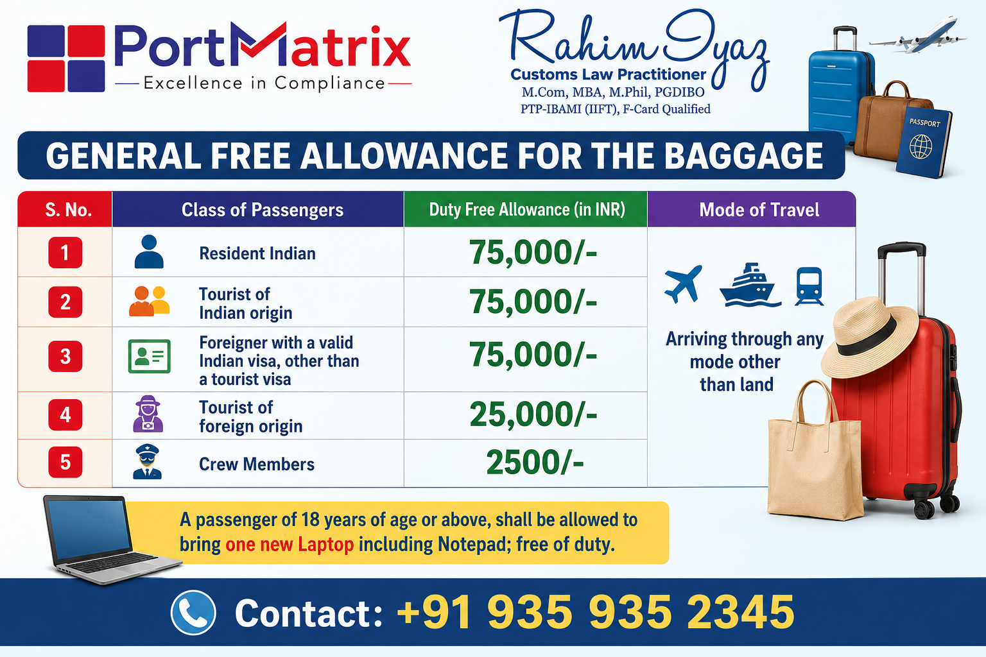
Passengers carrying goods beyond the permissible limit, restricted items, or prohibited goods must declare them to Customs and pay the applicable duty. Failure to declare dutiable goods may result in confiscation, penalty, or prosecution under the Customs Act.
Special allowance for jewellery
A resident or tourist of Indian origin who has been residing abroad for more than one year can carry jewelry duty free as follows:
Duty free eligibility for Gold jewellery
Gender | Eligibility
Female | 40 gms
Male | 20 gms

Transfer of residence (NRI passengers shifting their residence to India)
Transfer of residence allowances is available to eligible persons to carry their personal and household articles, according to the duration of their stay abroad and the period of stay in India. The allowances are applicable only to bona fide (used articles) household effects and personal articles, and are subject to specified conditions and exclusions.
The following allowances are available to eligible passengers under transfer of residence, according to the duration of their stay abroad.
Allowance for Indian Residents / Tourists of Indian Origin
Duration of stay abroad | Allowance in INR
3 -12 months | 1,50,000
Minimum 1 year during preceding 2 years | 3,00,000
More than 2 years | 7,50,000

Allowance for Foreigner with a valid visa, other than tourist visa
Duration of stay in India | Allowance in INR
6 -12 months | 1,50,000
1 - 2 years | 3,00,000
More than 2 years | 7,50,000
More than 2 years | 7,50,000

Generally, specified personal/household articles may include not more than one unit each of items listed in Annexure-II, subject to the applicable conditions.

Annexure-II — Examples of Transfer-of-Residence Items:

Category | Examples
Home appliances | Air-conditioner, microwave oven, washing machine, refrigerator
Kitchen | Gas cooking range, dishwasher, electric oven, air fryer, water dispenser, oil heater
Electronics | Home Theatre, Laptop, desktop PC, TV, tablet, printer, projector, Video Camera,
Entertainment | PlayStation/gaming console, small Bluetooth speakers, amplifier
Household | Refrigerator, Deep freezer, Vacuum cleaner, robotic vacuum, air purifier, dehumidifier, air cooler
Other | Musical instruments, massage chair, water dispenser, oil heater

Re-import of Personal Effects:
- Certain personal effects taken out of India earlier may be re-imported duty-free subject to declaration and Customs satisfaction.
Temporary Import by Tourist:
- Personal effects required during stay may be temporarily imported duty-free, subject to declaration and re-export.
Unaccompanied Baggage:
- Generally allowed; normally dispatched within 1 month after arrival.
- Customs may permit earlier arrival, including up to 2 months before arrival, subject to specified conditions.
Currency:
- A passenger can carry USD 5,000 or equivalent in cash; and a total aggregate of foreign exchange in the form of currency notes, bank notes, or travellers cheques allowed is USD 10,000 or equivalent. When this limit is being exceeded, then a formal declaration is made to the Customs Authorities.
- Any person resident in India may take outside India Indian currency notes not exceeding INR. 25,000.
Pets
- Resident, tourist of Indian origin, foreigner with a valid visa, other than tourist visa are allowed to import two pets (cat and Dog) under Transfer of residence in the case of two years stay abroad or more; subject to declaration an advance No Objection Certificate (NOC) from Animal Quarantine and Certification Services or a DGFT import authorization.

16. Postal Export
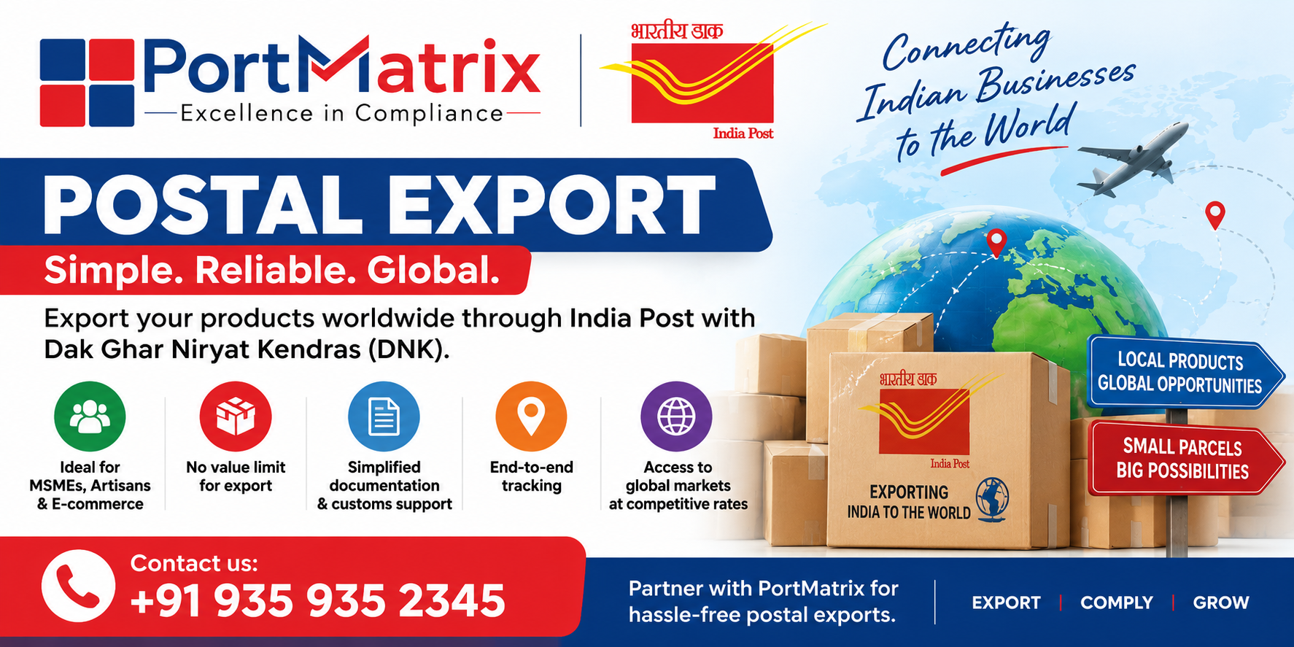
E-Commerce Exports through India Post, especially for MSMEs, start-ups, artisans, weavers, craftsmen, and e-commerce exporters.
- Dak Ghar Niryat Kendras (DNKs) established to facilitate exports through India Post.
- Registration, customs procedures, and Postal Bill of Export (PBE) requirements.
- Key documents such as **IEC, GSTIN, bank account and AD Code.
- Product classification, permissions, and export compliance.
- DNK portal booking, shipment tracking, and documentation requirements.
- Benefits such as pay-for-exact-weight, end-to-end tracking, and access to postal export services.
- Contractual customer benefits and volume discounts.
- List of operational **Dak Ghar Niryat Kendras across India.
- Encouragement for exporters to register on the DNK portal and start exporting through India Post.

17. E-Commerce Export

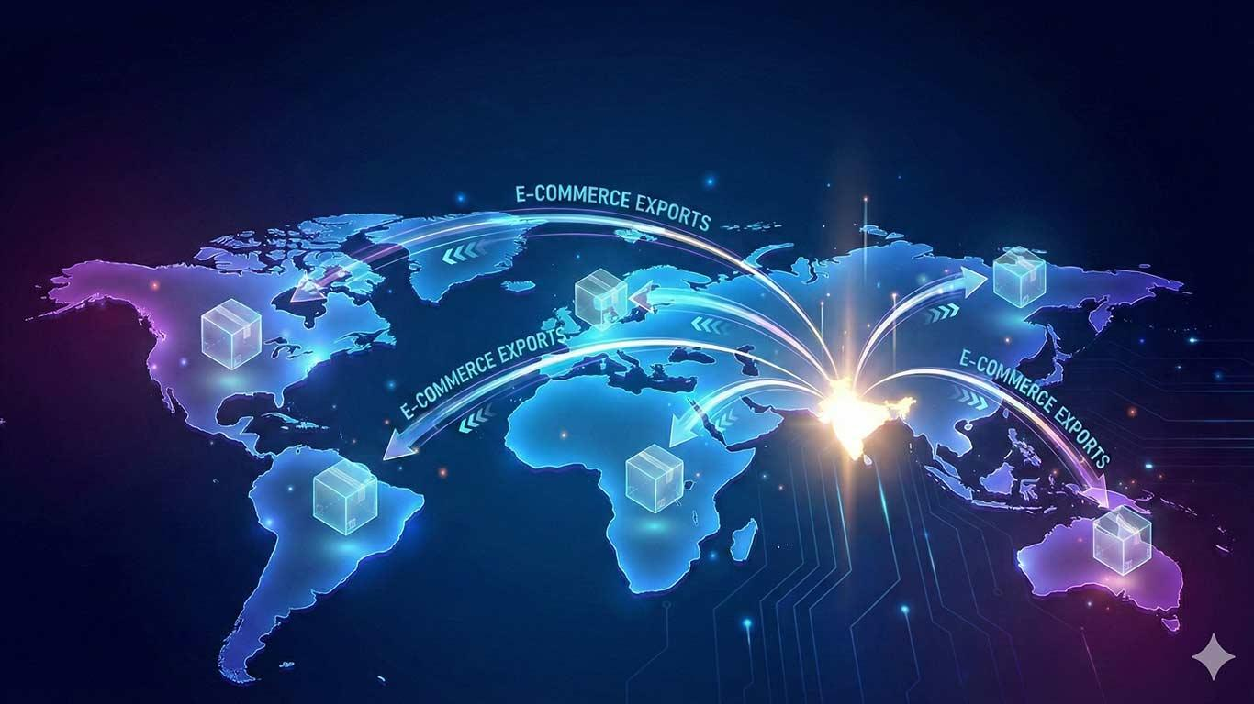

E-commerce export refers to the sale of goods from India to overseas customers through online platforms, websites, marketplaces, or direct-to-consumer channels.
↓

PORTMATRIX trains entrepreneurs in the segment of E-Commerce export

Key Features
- Online order placement by foreign buyers.
- Small-value shipments exported through courier, postal, or express cargo channels.
- Faster access to global markets without establishing a physical presence abroad.
- Suitable for MSMEs, startups, artisans, and manufacturers.

Popular E-Commerce Export Platforms
- Amazon Global Selling
- eBay
- Etsy
- Alibaba.com
- Flipkart (cross-border initiatives)

Requirements for E-Commerce Export from India
- Import Export Code (IEC)
- GST registration (where applicable).
- Bank account for receiving export proceeds.
- Registration on e-commerce marketplaces or own website.
- Compliance with Indian Customs and foreign country import regulations.

E-Commerce Export Process Flow
Product Listing in the E-Commerce Portal
↓
Foreign Customer Order
↓
Online Payment
↓
Packing & Labelling
↓
Customs Clearance
↓
Courier / Postal Dispatch
↓
Delivery to Overseas Buyer
↓
Export Proceeds Realisation

Benefits
- Access to customers worldwide.
- Lower marketing and distribution costs.
- Faster order processing.
- Increased export opportunities for MSMEs.
- Government support through export promotion schemes.

Government Support
Indian e-commerce exporters can also benefit from:
- DGFT Incentives Scheme
- Export Promotion Capital Goods (EPCG) Scheme
- Advance Authorisation Scheme
- Authorised Economic Operator

Major Products Exported Through E-Commerce
- Handicrafts
- Textiles and garments
- Jewellery
- Leather products
- Home décor items
- Ayurvedic and wellness products
- Engineering products
- Consumer goods

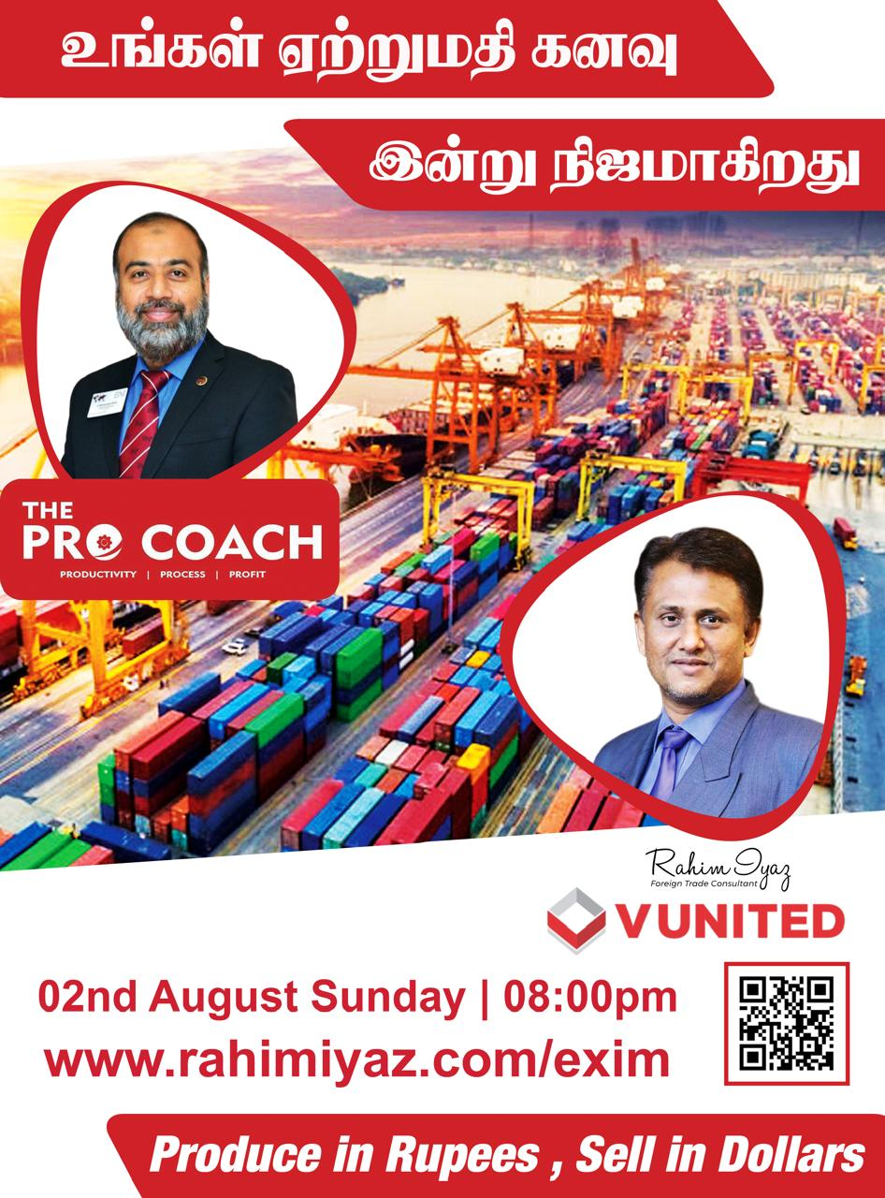
Our First Export Training was started on 2 August, 2020

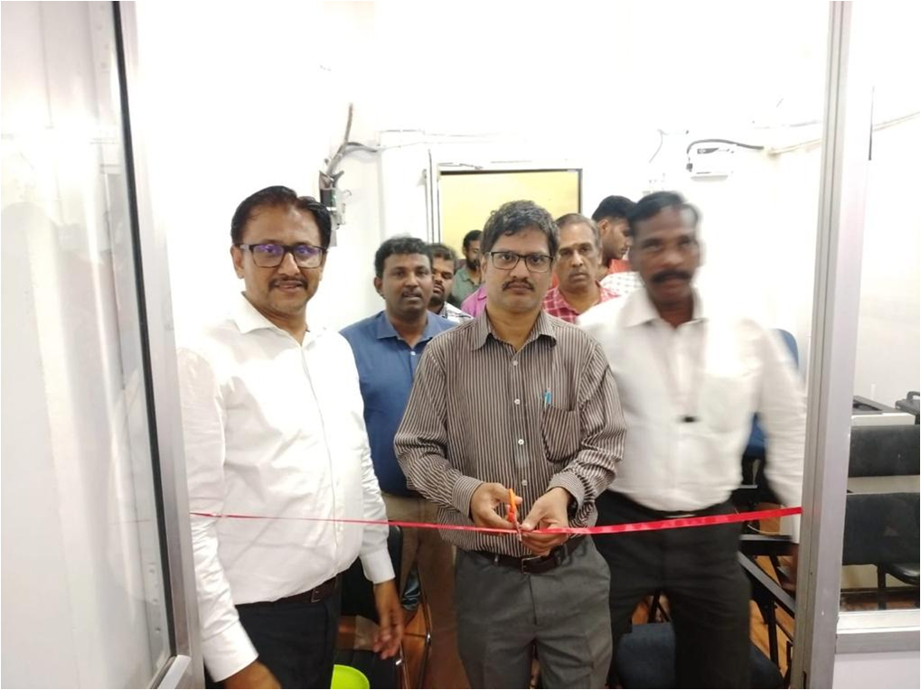

MSME DFO Assistant Director Mr. M V Leelakrishnan has inaugurated our RIIT Training Center in Chennai on 14 November, 2023

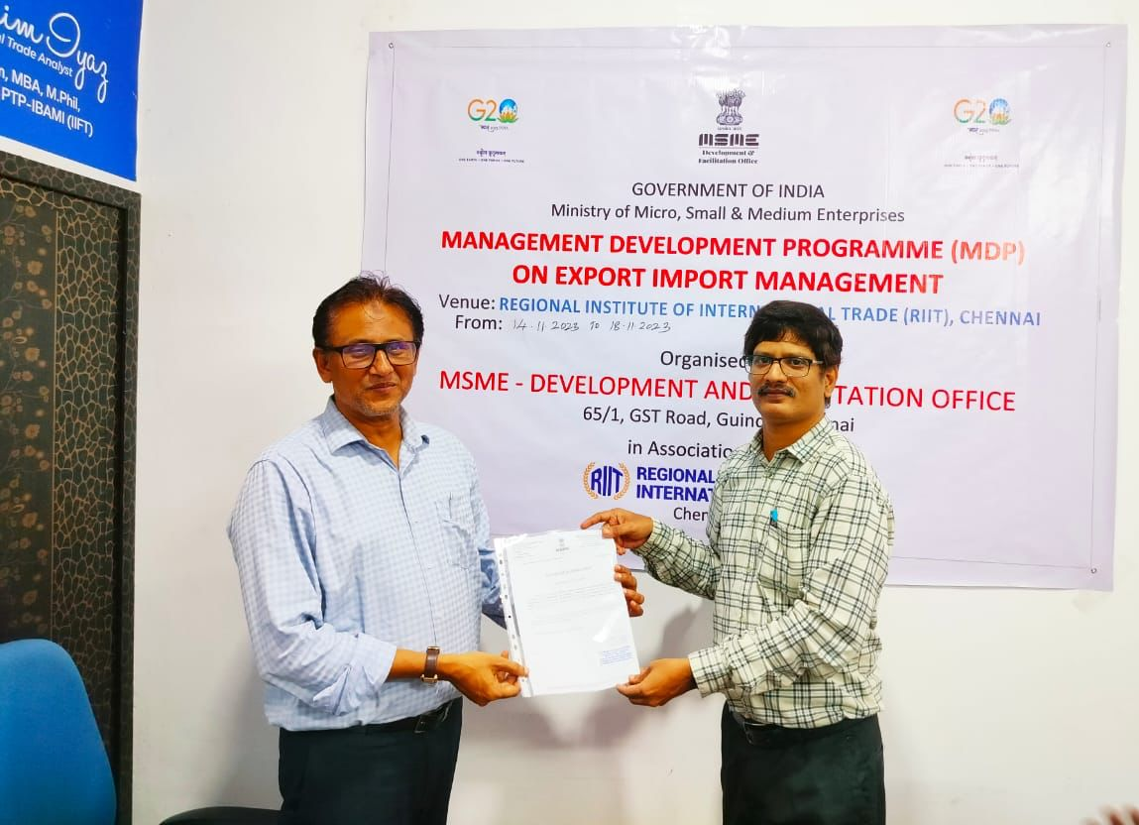
Certificate of Appreciation from Mr.Leelakrishnan, Assistant Director, MSME DFO, Guindy, Chennai to our MD Mr. Rahim Iyaz
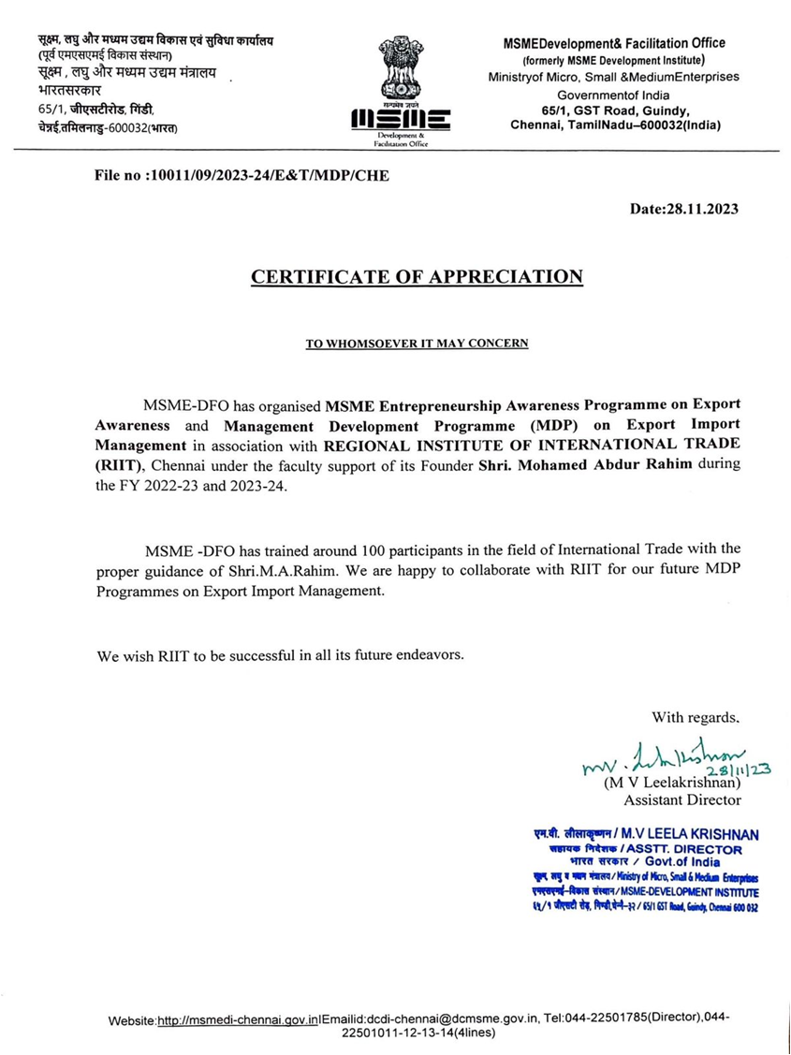

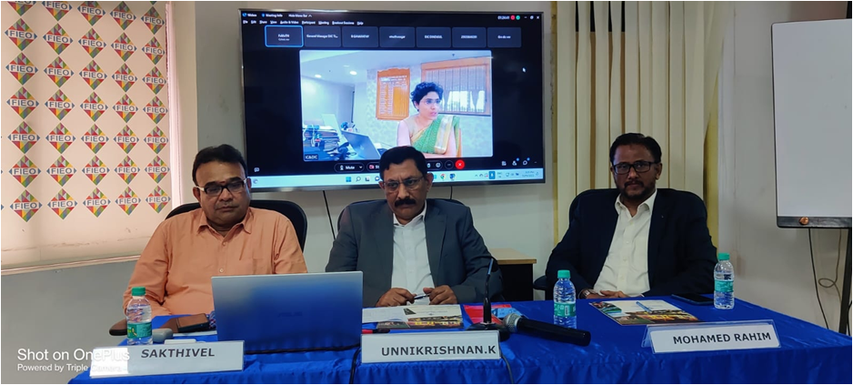
Our MD Mr.Rahim Iyaz with GM of FaME-TN Mr.Sakthivel and Jt. Director General of FIEO Mr.Unnikrishnan at Federation of Indian Export Organisations (FIEO) Training on 20 December, 2022

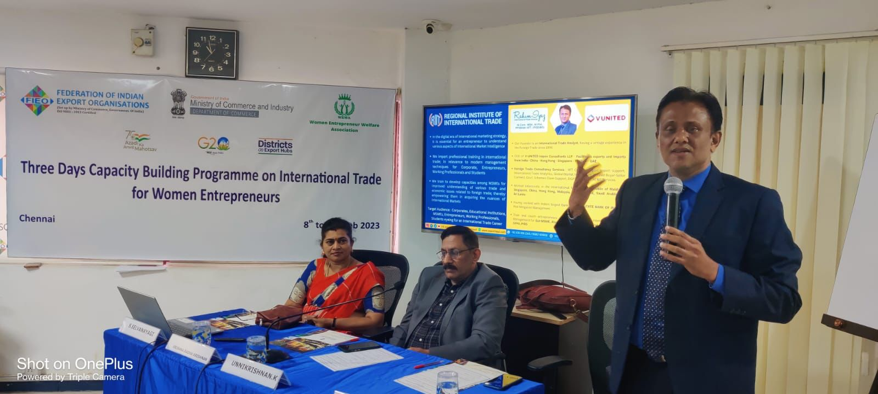
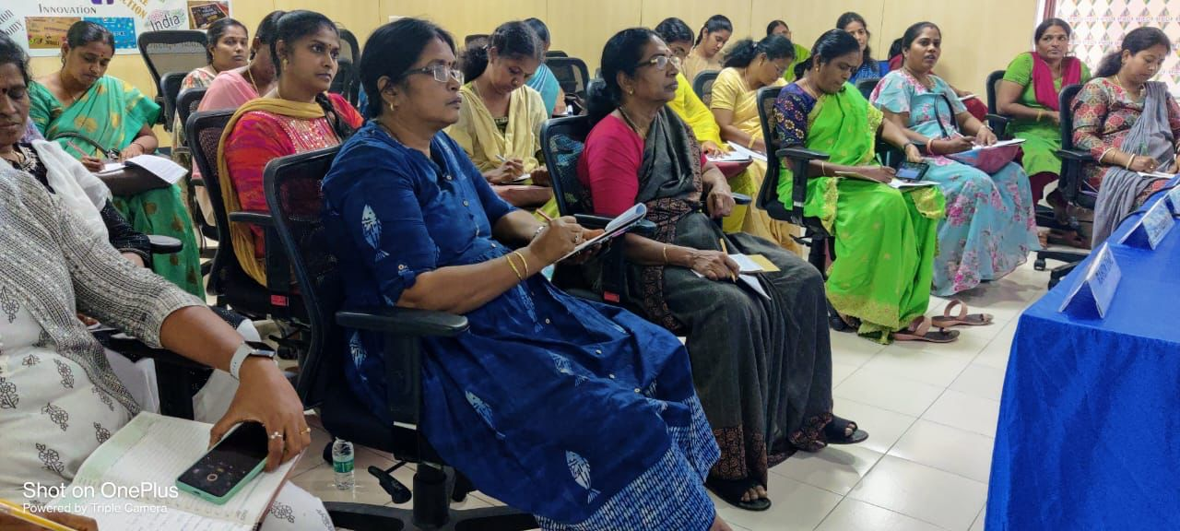
Federation of Indian Export Organisations (FIEO) Training for Women Entrepreneurs on 9 February, 2023

Export Training to Govt. of Tamil Nadu, MSME Officials across Tamil Nadu on 26 March, 2023


Facilitation to our MD Mr. Rahim Iyaz by Ms. Shiju Thomas, IAS, Secretary for MSME Department of FaME-TN, Govt. of Tamil Nadu on 26 March, 2023

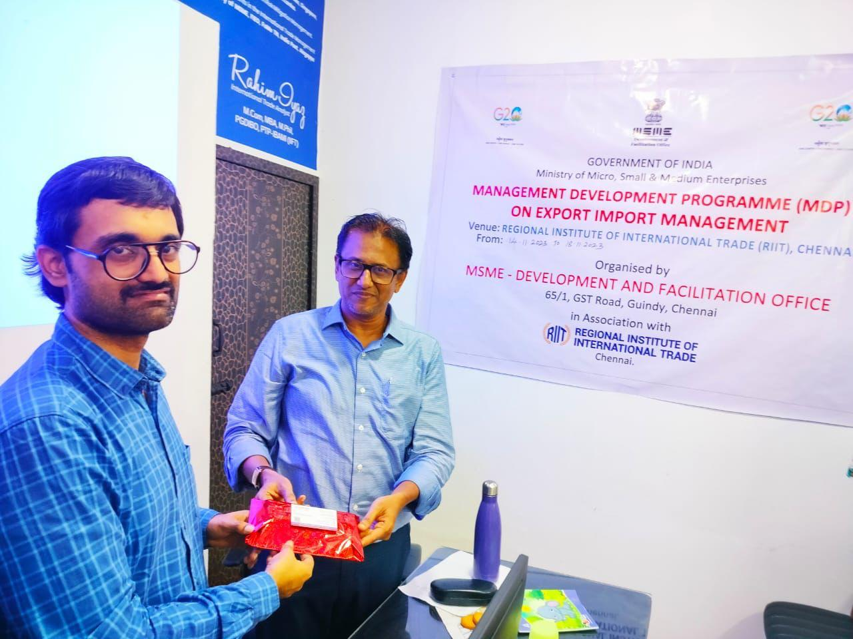
Deputy DGFT Mr. K.H. Reddy is seen along with our MD Mr.Rahim Iyaz. Mr.Reddy has taken a Session on DGFT Procedures to our MSME MDP Participants at our RIIT on 19 November, 2023

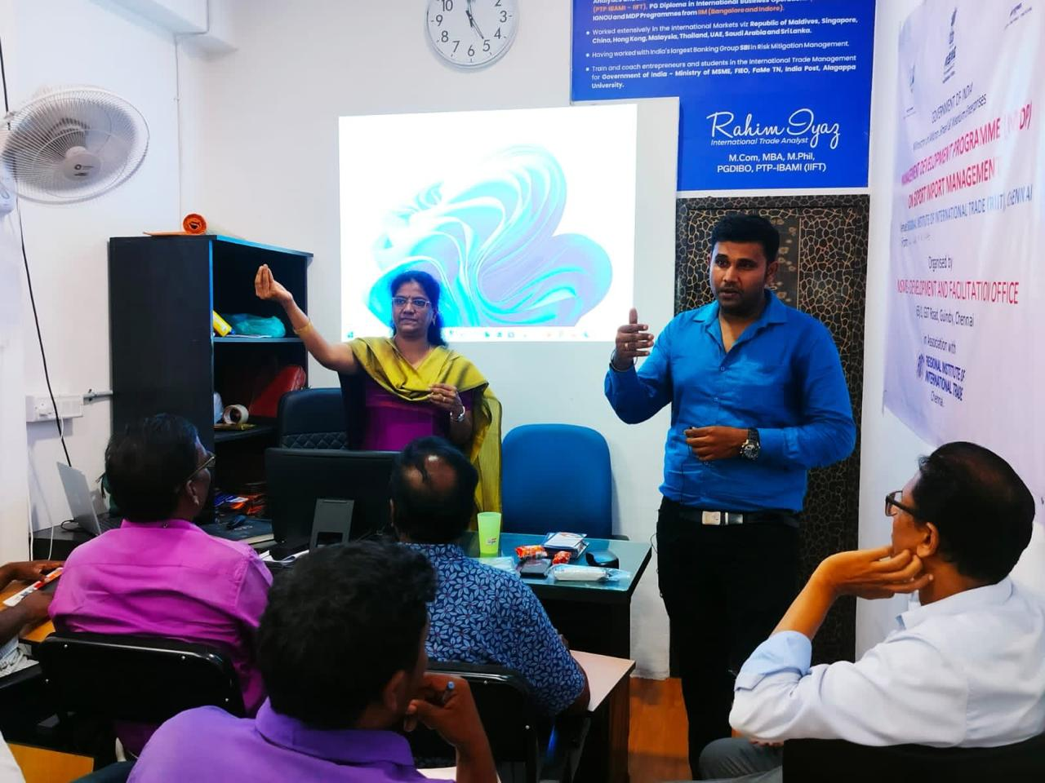
Superintendent of Foreign Post Office Ms. Kalyani and Mr. Prem Rajkumar, Postal Export Marketing Executive taking a Session on Postal Export Procedures to our MSME MDP Participants at our RIIT on 16 November, 2023

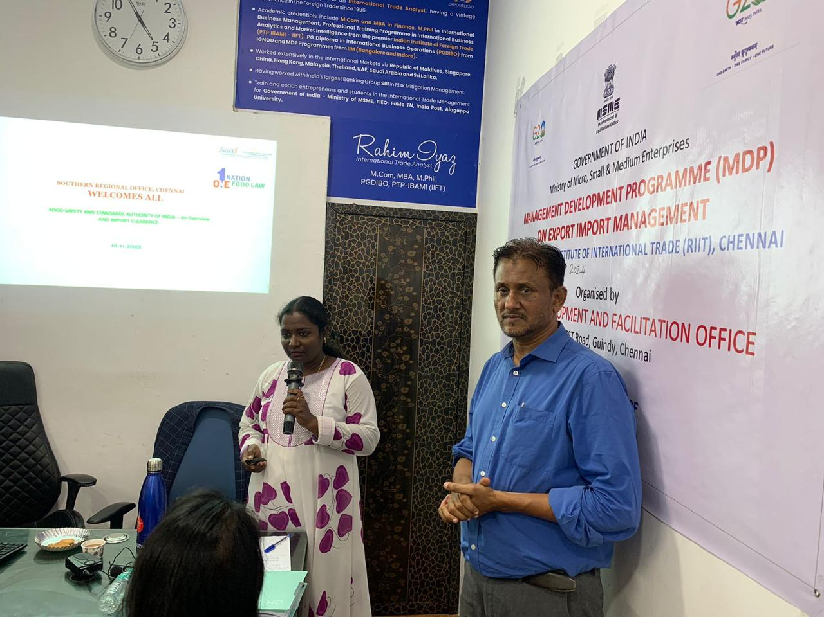
FSSAI Officer Ms.Rohini is taking a Session on FSSAI Procedures in food imports to our MSME MDP Participants at our RIIT November 2023

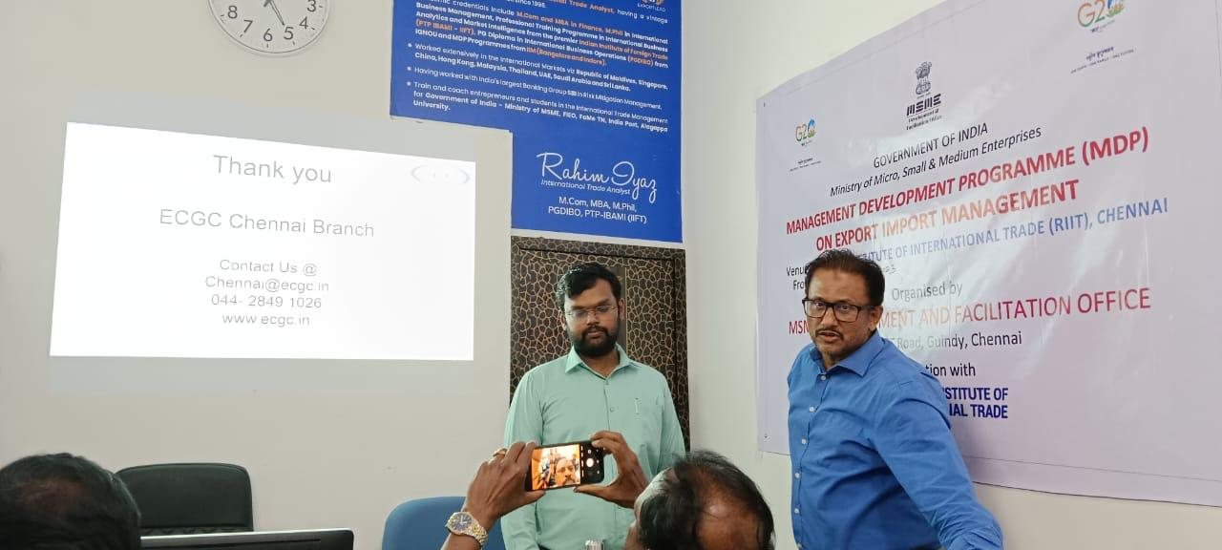
ECGC Mr.Subha Vignesh is taking a Session on ECGC Procedures in exports to our MSME MDP Participants at our RIIT in November 2023

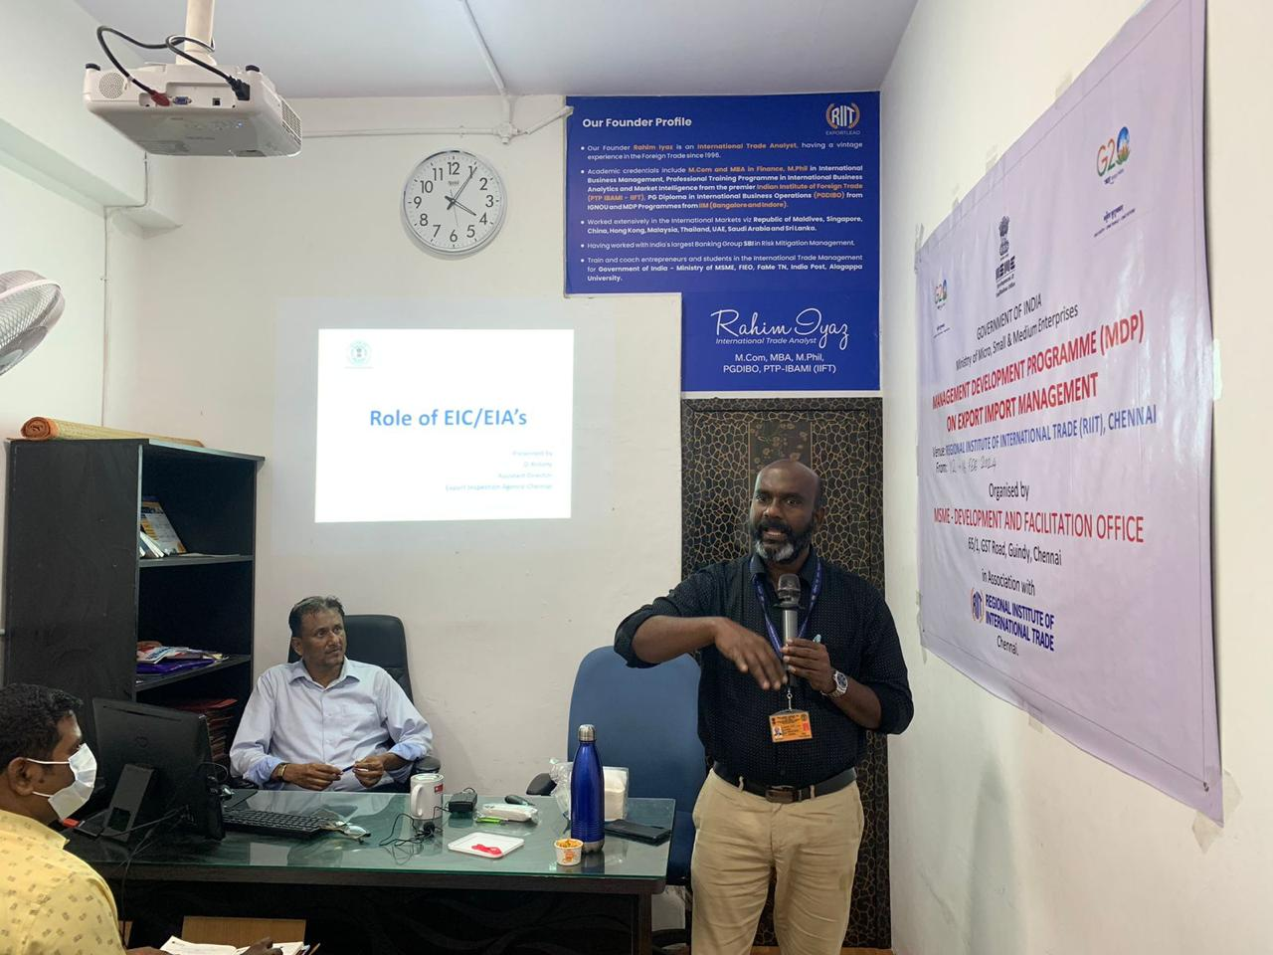
Govt. of India’s Export Inspection Agency (EIA) Director Mr.Antony is taking a Session on EIA Procedures in exports to our MSME MDP Participants at our RIIT in November 2023

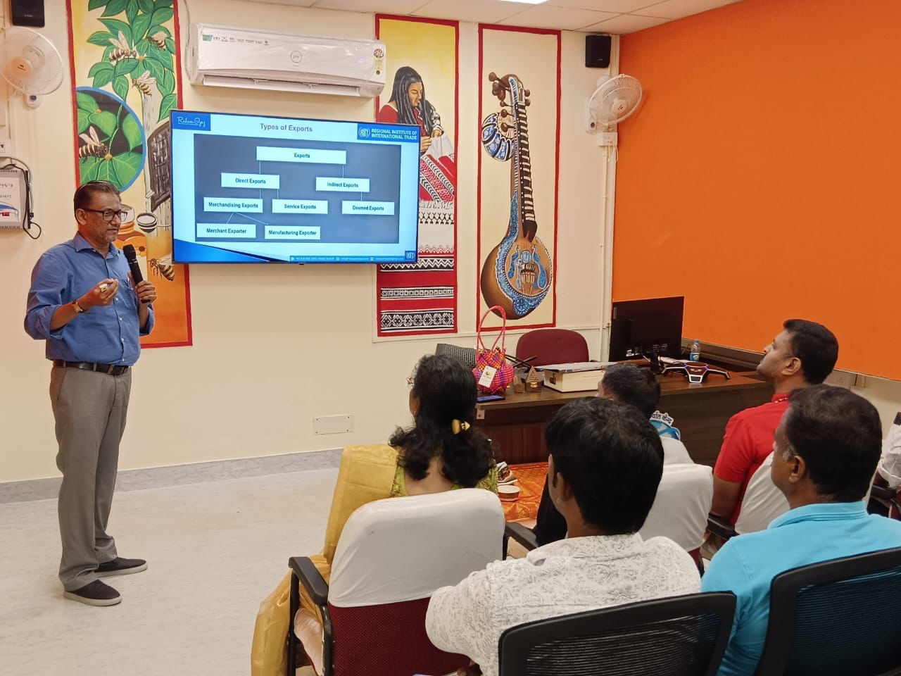
India Post Training at Foreign Post Office in Chennai on 25 January, 2024

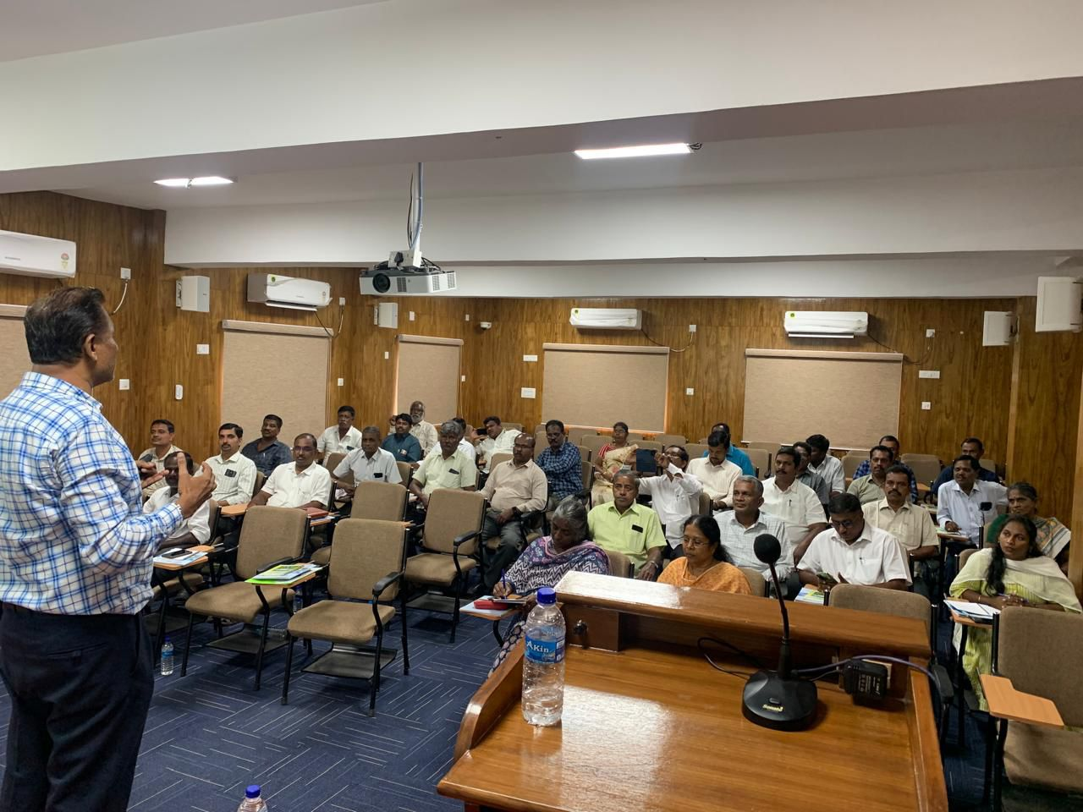
Agriculture export training In Chennai at EDII -TN Campus for around 40 Government Senior Officials of Cooperative Society on 12 August 2025. The training programme was organised by Govt. of Tamil Nadu TNAPEx and EDII-TN.

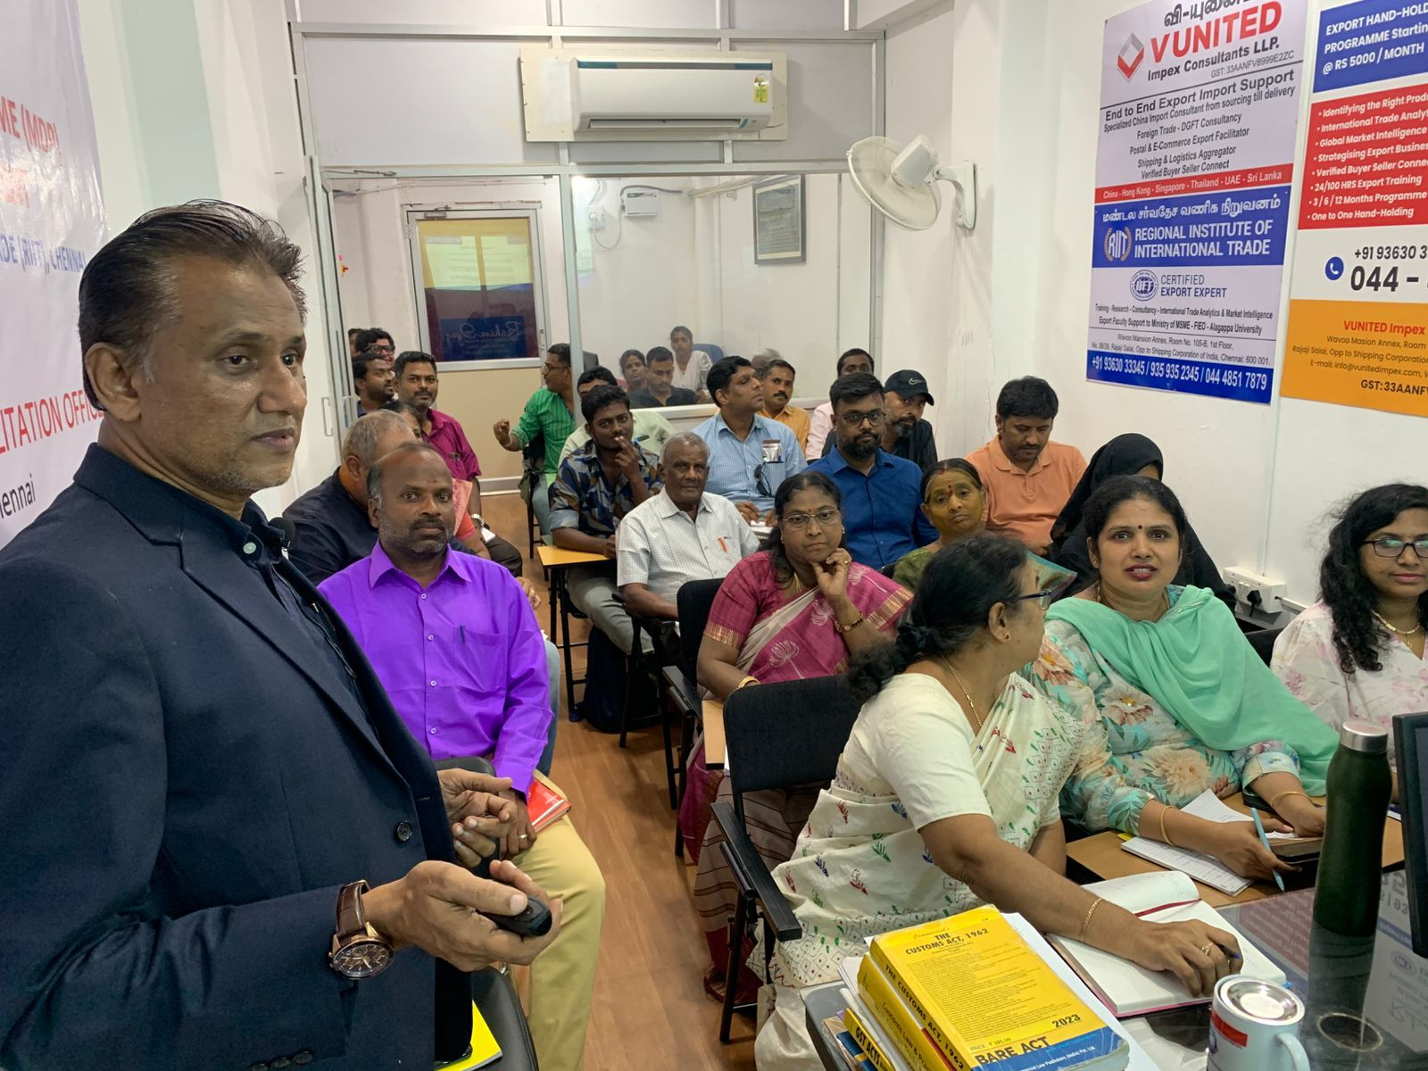
Govt. of India MSME-DFO MDP Programme on Export Import Management in 2025 at our RIIT Campus.

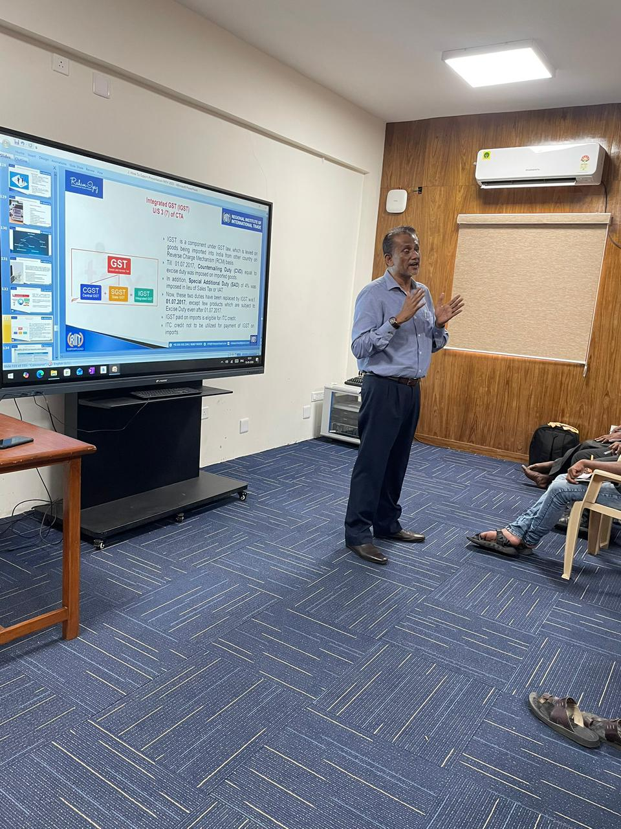
A session on Agricultural Export Procedures for Agri Entrepreneurs on behalf of Tamil Nadu Government Entities EDII-TN and TNAPEx on 13.05.2026.


An MoU was signed between Alagappa University, Karaikudi and RIIT to promote training and research in International Trade on 31st October, 2022.
Prof G. Ravi, Vice Chancellor of Alagappa University, Karaikudi is presenting the MoU document to our MD Mr.Rahim Iyaz.
Dr.Gurumoorthy, HOD of Dept. of Commerce, Dr. Muthusamy, HOB of Dept. of MBA (International Business) are seen together

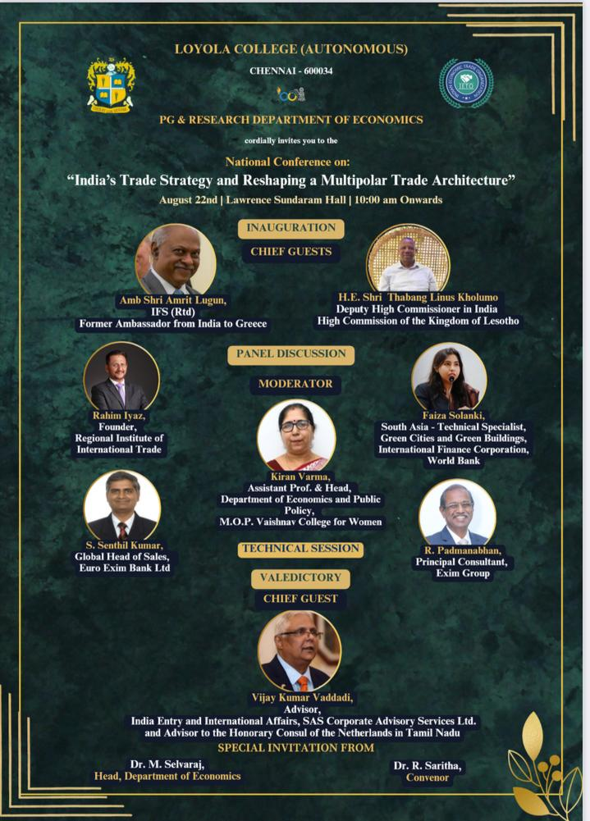

“India’s Trade Strategy and Reshaping a Multipolar Trade Architecture” - Seminar in the prestigious Loyola College, Chennai on 22 August, 2025

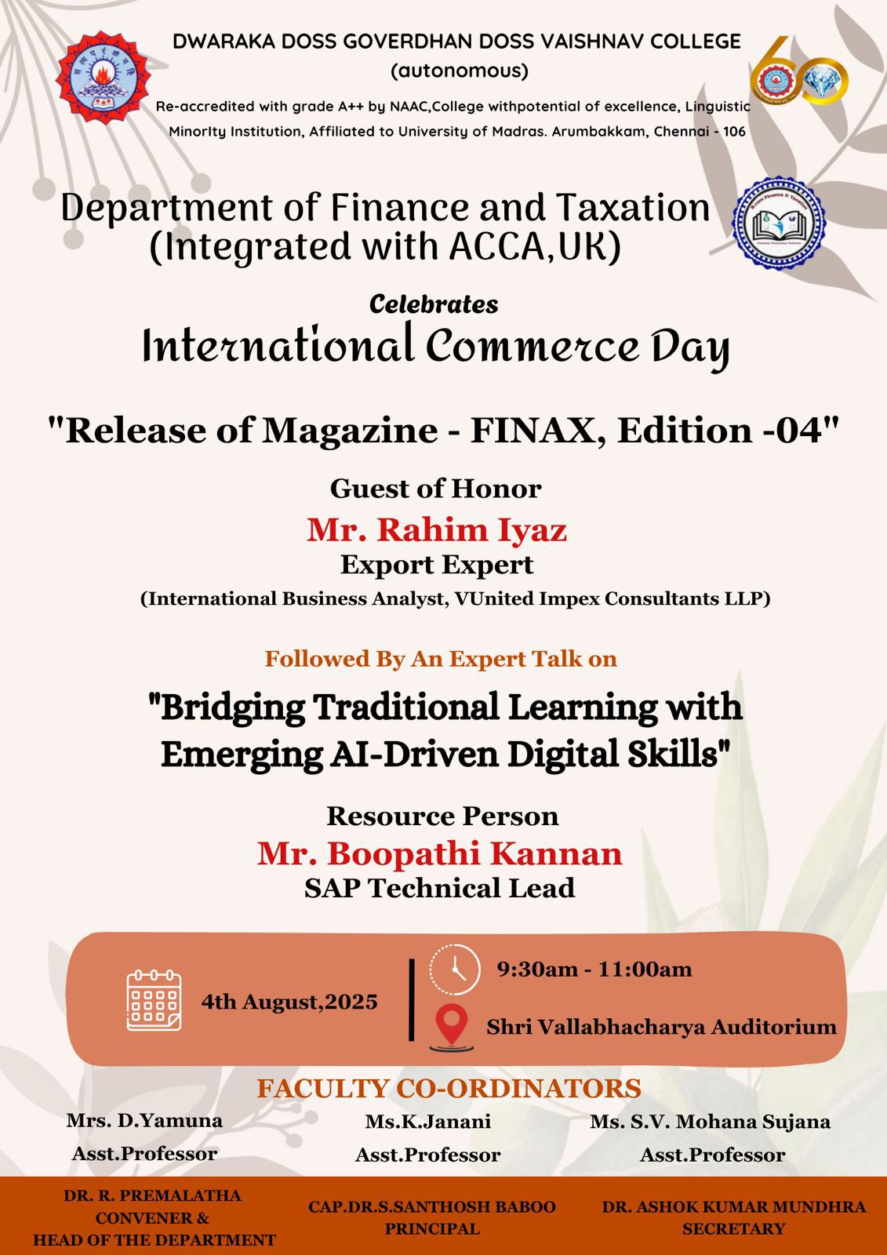
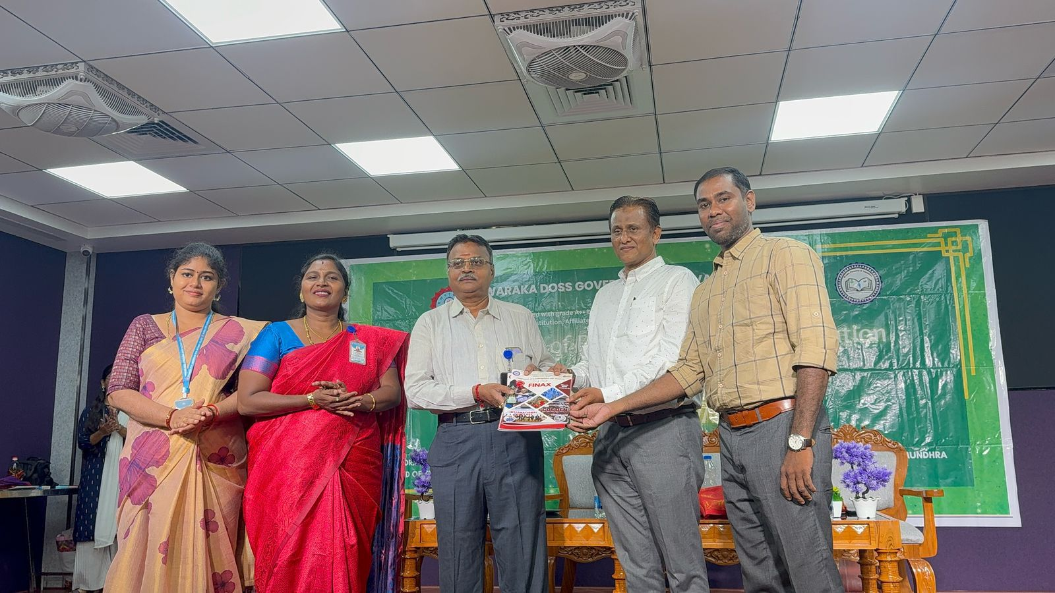
International Commerce Day Celebration of DG VAISHNAV COLLEGE, Chennai on
4 August, 2025

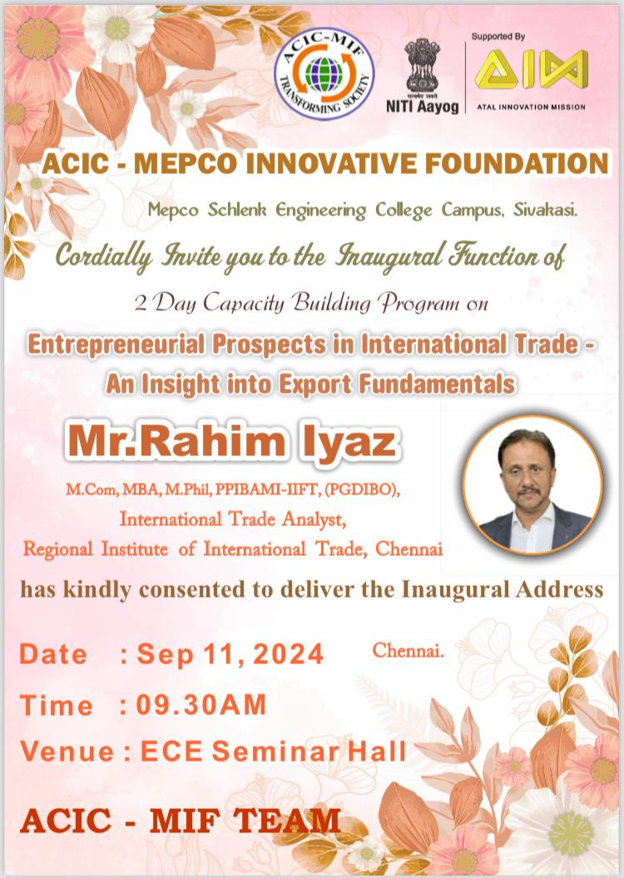
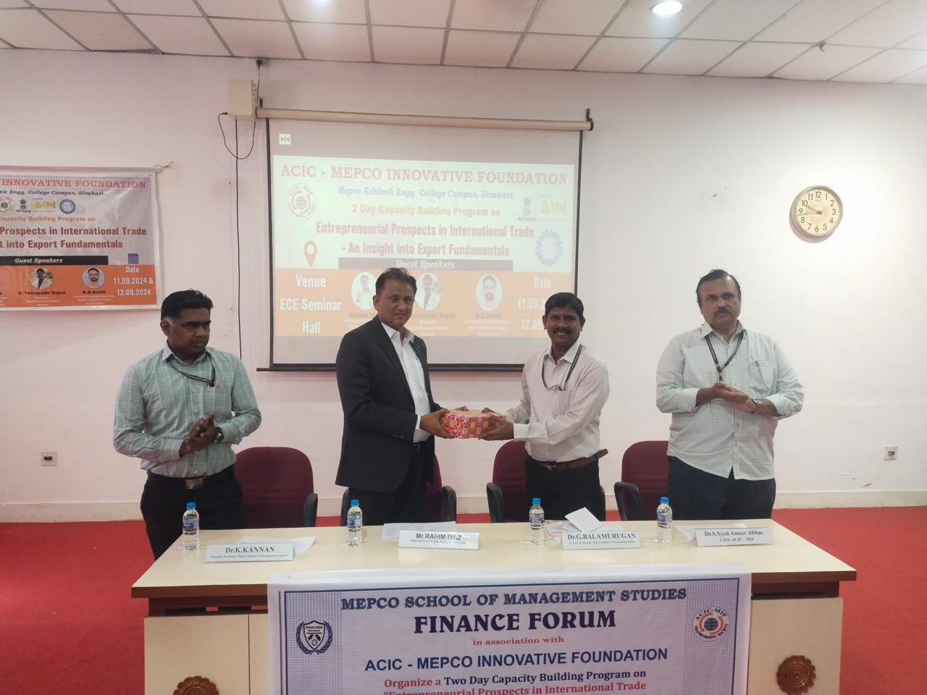
Entrepreneurial Prospects in International Trade at MEPCO Engineering College, Sivakasi on 11 September 2024


Export Orientation Programme at SIET College (Presently known as JBAS College, Chennai) on 12 July, 2023
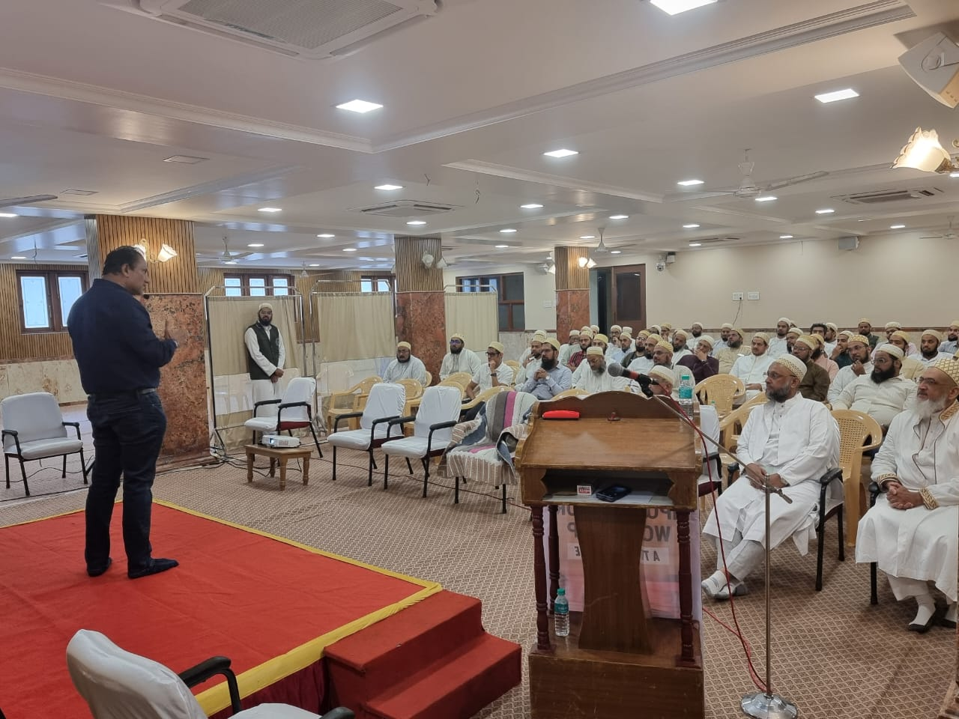
Import Export Workshop for Dawoodi Bohra Muslim Community on 8 September, 2024 in Chennai

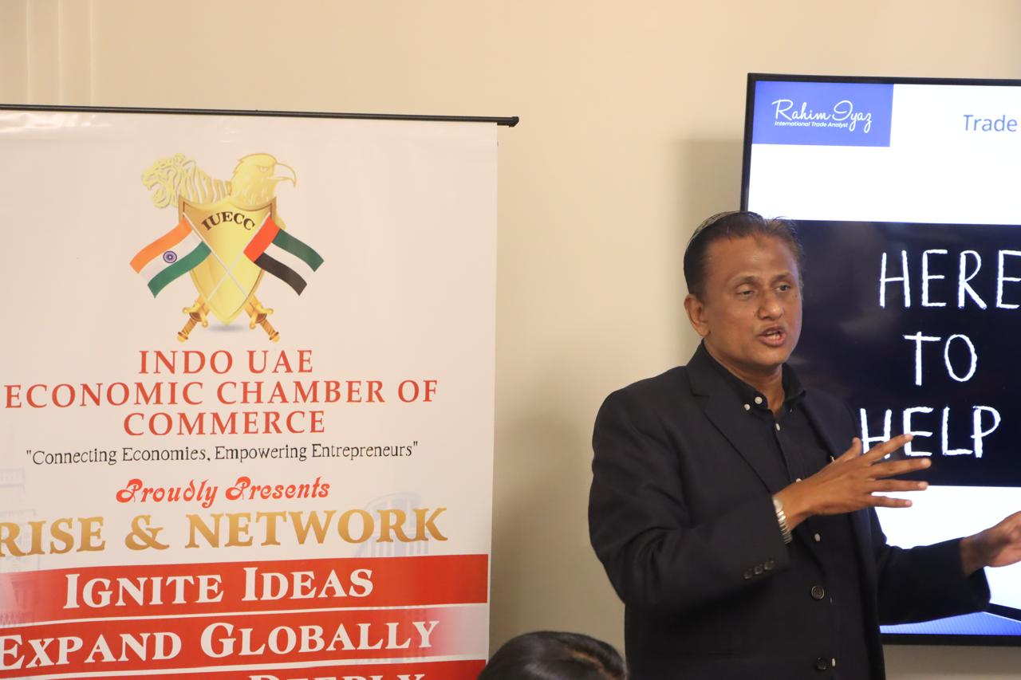
Indo - UAE Economic Forum on 9 August, 2025 at Hotel Novotel, Chennai

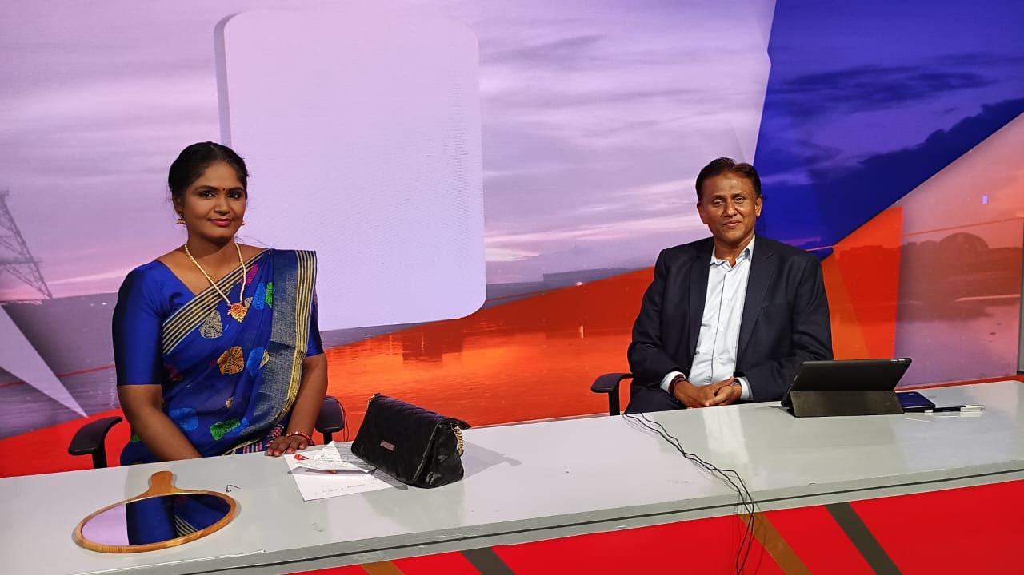

Interview YOUTUBE Link: https://www.youtube.com/live/K28p2YTy2OI?feature=shared

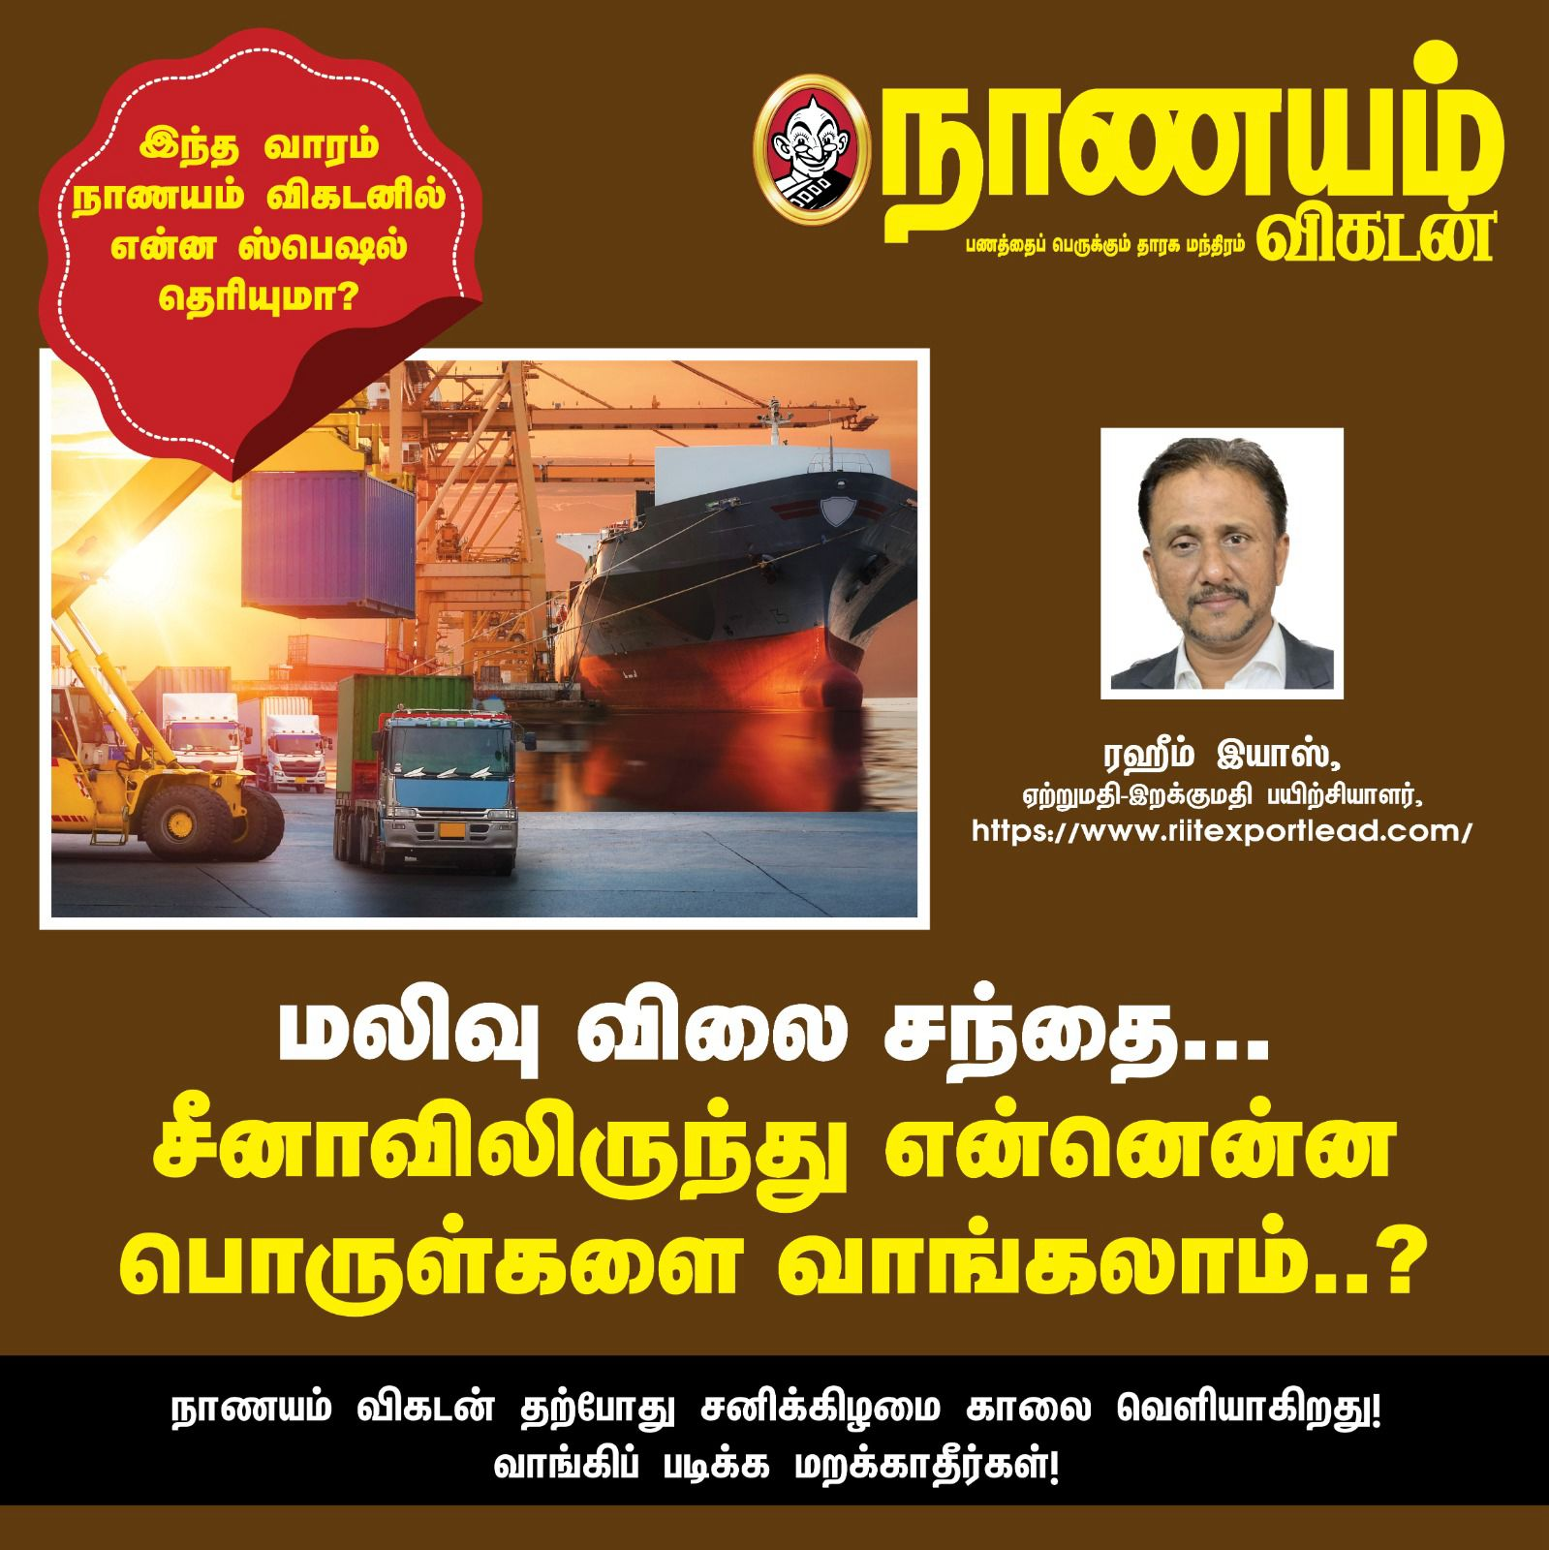
Our MD’s China Import Article in NANAYAM VIKATAN Tamil Magazine on 04 February, 2024
Certificate Programmes in International Trade Management
Course Introduction:
The courses are conducted by both Online and Physical modes. It consists of a wide range of subjects covered across the International Trade spectrum. By registering the course, you will have in-depth knowledge, acquaintances, practices, regulations and nuances of the foreign trade procedures.
Who Shall take this course?
G-Card Exam Takers, MSME Entrepreneurs, Corporate Institutions, Working Professionals, Graduates looking for an International Trade career.
Course Curriculum:
- Customs Act. 1962
- Customs Tariff Act, 1975
- Foreign Trade Policy 2023
- Customs Clearance Procedures with Software demo
- GST in EXIM
- FEMA 1999
- All Allied Acts for Customs Clearance
- EXIM Documentation
- INCOTERMS 2020
- Export Pricing Strategy
- Export Payment - LC
- Export Finance
- Export Promotion Schemes (Advance Authorisation, EPCG, RoDTEP, Duty Drawback)
- Postal / E-commerce Export
- Fast Moving Exportable Goods (FMEG)
- Banking in International Trade
- Export Risk Mitigation
- International Trade Logistics
- Import Procedures
- International Trade Marketing
- Finding Foreign Buyers

Allied Services
EXIM Company Setup:
- ⁠Company / Firm / Proprietary
- GST registration
- Importer Exporter Code (IE Code)
- Export Promotion Council RCMC / FSSAI / MSME Udayam / PGA registration
- Digital Signature
- ICEGATE registration

EXIM Compliance & Consulting:
- Advisory under The Customs Act
- Foreign Trade Policy (FTP) / FTDRA
- Export Promotion Schemes
- ⁠IGST / FEMA
- Customs Audit & Risk Management
- Advance Rulings
- Intellectual Property Rights (IPR)

EXIM Value Added Services:
- ⁠Procedure to claim preferential rate of duty under Free Trade Agreement (CAROTAR)
- ⁠Postal Export procedures
- Status Holder Certification
- EOU / EHTP / STP / BTP / SCOMET / BIS Certification
- Procedure on Transit & Transhipment of Cargo
- Coastal Goods filing
- Procedures on Re-importation & Re-exportation of Goods

Target Audience:
- MNC / Corporate Clientele
- MSME Manufacturers
- Merchant Exporters / Importers
Key Strengths:
- Error-free documentation
- Faster clearance turnaround
- Good liaison with Partner Government Agencies (PGAs)
Registered Office:
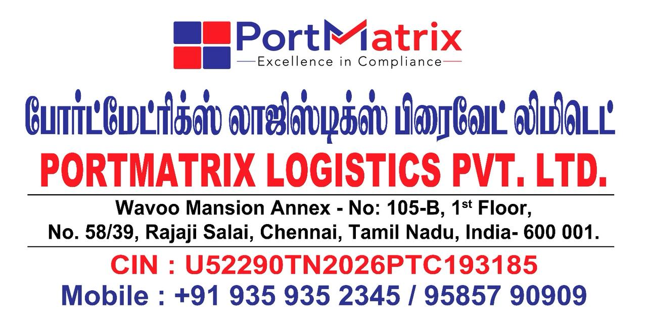

Contact:

PORTMATRIX Logistics Pvt. Ltd.
Wavoo Mansion Annex - 105-B - I Floor,
No. 58/39, Rajaji Salai North Beach Road,
Chennai: 600 001, Tamil Nadu, India.
Contact: +91 935 935 2345 / 95857 90909
Email: md.portmatrix.in
Website: www.portmatrix.in

